

**Department of Computer Science**

This project has been satisfactorily demonstrated and is of suitable form.

This project report is acceptable in partial completion of the requirements for the Master of Science degree in Software Engineering.

|  |  |  |
| --- | --- | --- |
| A Tea Online Shopping Website - Teamee | | |
| Project Title | | |
| Holly Do |
| Student Name |
| Ning Chen, Ph.D. |
| Advisor's Name |
|  | |
| Advisor's signature | Date |
| Bin Cong, Ph.D. |
| Reviewer's Name |
|  | |
| Reviewer's signature | Date |

# Abstract

This project is an online tea and coffee store that provides users with information about the Teamee company, and allow the user to place orders on the website. Ecommerce is a blooming industry that encompasses various goods and services.3 It is necessary in today’s world for any company that sells products or services to have a website. The Teamee website is highly customizable and uniquely different from the typical Wordpress website.

This is a developmental project; thus, the core of the report would be within all my documentations of my project. There will be a total of three documents: the SRS, design, and test plan. The SRS document provide a detailed description of the Teamee system. The design document contains an outline of how the Teamee system will be implemented to satisfy all the requirements listed in the SRS. Finally, the test plan document will contain the methods that were used to ensure that the Teamee system is held to the highest quality. However, the primary document for my project would be the SRS (software requirement specification). It contains all the information necessary to describe what my project is about and a full description of the Teamee system.

The creation of the Teamee website will help increase its potential customer base. Anyone with internet access can view the website. Also, the Teamee online store provides users a convenient way to skip the line and procure goods from Teamee to satisfy their craving. The convenience is extended to employees since the online store will also be beneficial for Teamee’s employees. The Teamee system will provide a way for admin to track and fulfill orders. Additionally, by providing information about the stores and products provided by Teamee, this will reduce questions that customers will have.

Table of Contents

Abstract 2

1.0 Introduction 7

1.1 Background 7

1.2 Problem Statement 7

1.3 Motivation for Project 8

2.0 Objectives 8

2.1 Improve programming skills 8

2.2 Demonstrate to future employers the capability to complete a whole project 8

3.0 Resources 8

3.1 Hardware 8

3.2 Software 8

3.3 Environment 9

3.4 Learning Resources 9

4.0 Planning and Staging 9

4.1 Timeline 9

4.2 Work Products 10

4.2.1 Product Increment 10

4.2.2 Product Backlog 10

4.3 Major Features 10

4.4 Product Backlog 11

4.5 Release Plan 12

5.0 Software Requirement Specification (SRS) Document 13

1.0 Introduction 13

1.1. Purpose 13

1.2. Document conventions 14

1.3. Product Scope 14

1.4. Definitions, acronyms, and abbreviations 14

1.5. References 14

1.6. Overview 15

2.0 Overall description 15

2.1. Product Perspective 15

2.2. Product functions 16

2.3. User classes and characteristics 16

2.4. Constraints 17

2.5. Assumptions and dependencies 17

3.0 System Features 17

3.1 About Us 17

3.2 Locations 17

3.3 Menu 17

3.4 Contact 18

4.0 Quality Attributes 18

4.1 Usability 18

4.2 Performance requirements 18

5.0 Functional requirements 18

5.1 FR-1: Register for an account 19

5.2 FR-2: Add item to cart 19

5.3 FR-3: Checkout items 20

5.4 FR-4: Search for the closest location 20

5.5 FR-5: View all locations 20

5.6 FR-6: Contact Teamee 21

5.7 FR-7: Sign up for promotions and news 21

5.8 FR-8: View user’s orders 22

5.9 FR-9: View website 22

5.10 FR-10: View all items sold by Teamee 22

5.11 FR-11: Check all order 23

5.12 FR-12: View all subscribers 23

5.13 FR-13: View user’s contact information 23

6.0 Logical database requirements 24

6.1 Design constraints 24

7.0 Software system attributes 24

7.1 Reliability 24

7.2 Availability 25

7.3 Security 25

7.4 Maintainability 25

8.0 Use Case 25

8.1 Use Case Descriptions 25

6.0 Software Design Document 32

1.0 INTRODUCTION 32

1.1 Purpose 32

1.2 Scope 33

1.3 Overview 33

1.4 Reference Material 33

2.0 SYSTEM OVERVIEW 33

3.0 SYSTEM ARCHITECTURE 33

3.1 Architectural Design 33

3.2 Decomposition Description 34

3.3 Design Rationale 34

3.4 System Context Diagram 35

4.0 DATA DESIGN 35

4.1 Data Description 35

4.2 Data Dictionary 36

5.0 COMPONENT DESIGN 36

5.1 Login Pseudocode 36

6.0 HUMAN INTERFACE DESIGN 36

6.1 Overview of User Interface 36

6.2 Screen Images 36

7. QUALITY ATTRIBUTES 37

7.1 Quality Attribute Scenarios 37

7.0 Test Plan 37

7.1 Summary 37

7.2 Background 38

7.3 Motivation 38

7.4 Objectives 38

7.5 System Requirements 39

7.6 Requirements to be Tested 41

7.6.1 System Requirements to be Tested 41

7.6.2 System Requirements Not Tested 42

7.7 Approach 42

7.8 Staff 42

7.9 Record Keeping 43

7.10 Testing Tools 43

7.11 Types of System Testing 43

7.11.1 Usability Testing 43

7.11.2 Regression Testing 44

7.13 Test Deliverables 44

7.14 Testing Environment 44

7.14.1 Hardware Requirements 44

7.14.2 Software Tool Requirements 44

7.15 Staffing and Training Needs 44

7.16 Test Schedule 44

8.0 Development 45

8.1 Iteration 1 45

8.1.1 Sprint Planning 45

8.1.2 Testing 49

8.1.3 Sprint Review 52

8.1.4 Retrospective Meeting 53

8.2 Iteration 2 54

8.2.1 Spring Planning 54

8.2.2 Testing 59

8.2.3 Sprint Review 60

8.2.4 Retrospective Meeting 61

8.3 Iteration 3 62

8.3.1 Sprint Planning 62

8.3.2 Testing 66

8.3.3 Sprint Review 67

8.3.4 Retrospective Meeting 68

Conclusion 68

References 69

Appendix A: Installation Guide 70

Download Xampp 70

Obtain Source code 70

Setup Laravel 70

# 1.0 Introduction

## 1.1 Background

As Amazon profit has shown, the ecommerce field is blooming. More and more consumers are using the internet to make purchases. Shopping online have many benefits for consumers which include:

1. Full catalog
2. Reviews posted by other customers
3. Shipped to home

In addition, companies also benefit from creating an ecommerce website. Expanding their business online would widen their customer base. Data can be collected from traffic through the website. Using the data collected, companies can determine market trends and customize their service towards their customer needs.

Generally, when ecommerce sites are mentioned, people think of Amazon, eBay, or other big name retailors. All kinds of products are sold on these websites. Then the food industry began to enter the internet space. In recent years, an emergence of websites and apps appear that allows consumers to order food or drinks online and have them delivered or ready to be picked up. Consumers have been shifting away from placing food or drink orders using the phone; and instead, they are using the internet to place orders.

## 1.2 Problem Statement

Online shopping has increased steadily throughout the years. Consumers increasingly looking towards online websites to procure goods and services. Thus, companies need to have their own website to attract potential customers. According to IBIS world, more people are connected online through their phones and online retail stores are a billion-dollar industry.2 In the future, any company will need a website to provide information about itself or sell products or services. Therefore, it is necessary to learn how to develop attractive and responsive website.

In addition, the food industry has been penetrating the online markets. For instance, Starbucks have a well-developed website and app to attract and retain their fans. Even Uber had created an app to deliver food. Dominos is another prime example of this trend since it allows the user to create and customize their pizza order. The website is easy to use and convenient to operate since it provides a full menu of Dominos’ selection. These flourishing examples demonstrated how services and goods can be rendered successfully online.

Food trends are constantly shifting, especially in regards to dessert. In the past, there were boba craze, ice cream, cupcakes, and other delectable treats that materialized. The US have a sweet tooth and it has proven to be insatiable.

## 1.3 Motivation for Project

My motivation for this project stems from the fact that I love tea. I hope to one day open a tea place for people to congregate and relax. I’ve always enjoyed gathering at a tea place with my friends; thus, it is my wish to own one in the future. This project had provided me with an opportunity to create a website and web app for my prospective store. Additionally, creating the Teamee web app had provided me with a project to show prospective employers. By building an ecommerce application, I had demonstrated a highly marketable skill as the ecommerce field is blooming. Furthermore, this project will help me demonstrate my ability to formulate a whole project from start to end.

# Objectives

The objective is to create a functioning website and web app with an easy to use UI. The creation of the website and web app serves the following purpose:

## 2.1 Improve programming skills

* + 1. Improve upon existing programming languages
    2. Learn new languages such as SQL to implement the backend of the project.

## 2.2 Demonstrate to future employers the capability to complete a whole project

* + 1. Create an effective software process to develop the Teamee website and web app
    2. Provide evidence of software process

# 3.0 Resources

## 3.1 Hardware

The hardware that was used to create this project is a Lenovo Thinkpad E570 with an Intel i7 core. The laptop is running with Microsoft Windows 10 Pro.

## 3.2 Software

4.2.1 Frameworks: Bootstrap v3.3.6, Materialize, Laravel

4.2.2 Microsoft Office 2016

4.2.3 Microsoft Visio 2013

4.2.4 GitHub

4.2.5 Adobe Photoshop 2017

I chose Bootstrap and Materialize as my frameworks for the UI because it is one that I am closely familiar with. I have used it to develop webpages before so I am confident that I can use it to create the UI for my website. Laravel was also chosen based upon previous work experience.

GitHub will be used as my source control and repository. GitHub was chosen because it is one of the most popular Git repository hosting service and I have used it before for work. As a result, it would be one less thing for me to learn.

Adobe Photoshop was used to design the logo and other photo manipulations. The main use of Photoshop was to crop pictures, logo placement in pictures, and modification of pictures. For a website to be attractive to users, it was necessary to produce quality pictures.

## 3.3 Environment

3.3.1 Atom

3.3.2 Brackets

Atom was chosen as my IDE because I have used it before and I am most familiar with its layout. Atom allow me to access all files from my project and I can easily create a new file through its navigation bar. I also listed Brackets because I intend to use it for my front-end development. Again, the reason why I chose Brackets is because I am familiar with it.

## 3.4 Learning Resources

There are numerous websites that are available to use as a resource for learning new languages. I will use w3school.com to review HTML, JavaScript, and CSS. Also, I will use w3school.com to learn SQL because I am already familiar with the website and the tutorials that I’ve found on w3school was constructive toward my understanding of HTML, Javascript, and CSS. I will use PHP for backend development to create my database since Laravel is a PHP framework.

Another resource that I am planning to peruse are the documentations available on each framework websites. Each framework contain documents that help developers understand their framework and it is useful to read up on these documentations.

# 4.0 Planning and Staging

## 4.1 Timeline

* Iteration 1: Create a basic Teamee website

Create layout of the website. Basic website with homepage, about us, contact, location, and menu page.

* Iteration 2: Improve Functionality and Connect to database

Implement backend of website. Create database and connect database to the website.

* Iteration 3: Satisfy business value and finalize the Teamee website

All functional requirements are completed. The website is thoroughly tested in this iteration.

## 4.2 Work Products

There are four work products associated with Scrum. The four work products are:

1. Product Increment
2. Sprint Backlog
3. Product Backlog
4. Burndown Chart

### Product Increment

The product increment is the product that is released after each sprint. The product should be a potentially shippable product that the customer can use and provide feedback upon. The product should contain all the use stories included in the sprint backlog. In addition, the product should be tested and documented.

### Product Backlog

The product backlog contains all the items that are necessary to complete the product. It represents what will be built. The items in the product backlog are flexible to change. Items in the product backlog can include features, use cases, enhancements, defects, and technologies.

* + 1. Sprint Backlog

The sprint backlog contains items from the product backlog. Items placed in the sprint backlog are considered the goals for that sprint. Items on the sprint backlog are delivered at the end of the sprint. At the end of each sprint, items for the next sprint are put into the sprint backlog. The categories for the sprint backlog are “Pending”, “Working On”, and “Completed”. All items began at pending, and are moved to working on when it is being implemented. Then after the item is finished and tested, it is moved to the completed section.

* + 1. Burndown Chart

The burndown chart is demonstrated the amount of work remaining across time. This chart is also used to keep track of the progress made throughout each sprint. Moreover, it is also used to reflect the progress made against the product backlog. The burndown chart is updated throughout the length of the sprint.

## 4.3 Major Features

FR-1 Register for account

FR-2 Add item to cart

FR-3 Checkout items

FR-4 Search for the closest location

FR-5 View all locations

FR-6 Contact Teamee

FR-7 Sign up for promotions and news

FR-8 View user’s order

FR-9 Check all orders

FR-10 View all subscribers

FR-11 View user’s contact information

FR-12 View website

FR-13 View items sold by Teamee

## 4.4 Product Backlog

|  |  |  |
| --- | --- | --- |
| **Name** | **Description** | **Story Points** |
| View website | As the user, I want to be able to view the Teamee website on my internet browser | 8 |
| Register for an Account | As the user, I want to be able to register for an account on Teamee so that I can view my orders. | 5 |
| Add item to cart | As the user, I want to be able to add an item to cart so that I can checkout my orders after I am done shopping. | 5 |
| Checkout items | As the user, I want to be able to checkout my items in my shopping cart so that I can pay and pick up my order at the store. | 21 |
| Search for the closest location | As the user, I want to be able to search for the closest Teamee store so that I can know which store to select to pick up my order. | 13 |
| View all locations | As the user, I want to be able to view all of Teamee’s locations so that I can plan a trip to any Teamee location. | 8 |
| Contact Teamee | As the user, I want to be able to contact Teamee so that I can ask a question or leave a comment. | 3 |
| Sign up for promotions and news | As the user, I want to be able to sign up for promotions and news from Teamee because I am a fan of Teamee and I want to get any savings from Teamee. | 3 |
| View user’s orders | As the user, I want to be able to view all of my orders that I had placed. | 8 |
| View Items sold by Teamee | As the user, I want to be able to view all items sold by Teamee so that I can order the items that I want. | 5 |
| Check all orders | As the admin, I want to be able to look up all the current pending orders so that I can fulfill them and satisfy my customers. | 8 |
| View all subscribers | As the admin, I want to be able to view all the users whom had signed up for an email subscription. | 3 |
| View user’s contact information | As the admin, I want to be able to view the user’s contact information so that I can contact them if something is wrong. | 5 |

Figure 1: product backlog contains all the features with a user story as the description for each feature.

All the functional requirements were placed into the product backlog with a description set as the user story. A story point is assigned to each functional requirement based upon the Fibonacci sequence. The Fibonacci sequence was used because it helped provided a relative estimate of each user story to create a more accurate estimate. Register for an account was used as the benchmark to compare the other user stories.

## 4.5 Release Plan

A release plan was created after the product backlog was completed. The release plan was created based upon the set timeline with 3 iterations. Each iteration was timeboxed to two weeks due to time constraint.

|  |  |  |
| --- | --- | --- |
| **Iteration 1** | **Iteration 2** | **Iteration 3** |
| Register for an account (5) | Add an item to cart (5) | Check all orders (8) |
| View all locations (8) | Checkout items (21) | View all subscribers (3) |
| Search for closest location (13) | View Items Sold by Teamee (5) | View user’s contact information (5) |
| Contact Teamee (3) |  | Signup for promotions and news (3) |
| View Website (8) |  | View user’s orders (8) |
| 37 | 31 | 27 |

Figure 2: A chart listing all the features to be completed per each iteration.

Iteration 1 contained the functional requirements that were deemed the most critical while the last iteration have the least number of story points. I wanted to keep risk at the lowest near the end of the project.

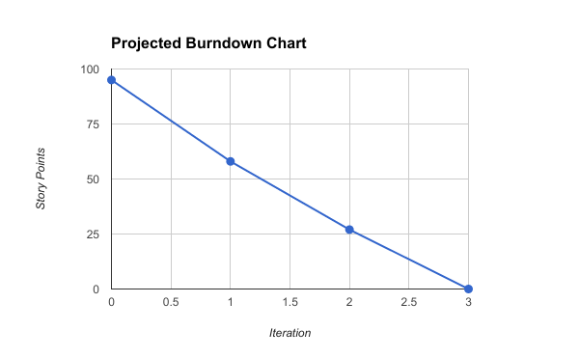

Figure 3: The projected burndown graph using all the story points for each iteration.

Based upon the product backlog chart that was produced, a projected burndown chart is created. This projected burndown chart will be used to measure the developmental progress. The total number of story points was 95 and after the first iteration it was expected that 37 story points should be completed. Then after the second iteration, another 31 points should be completed leaving only 27 story points for the last iteration.

# 5.0 Software Requirement Specification (SRS) Document

##### **An Online Shopping Website - Teamee**

Software Requirements Specification

## 1.0 Introduction

### 1.1. Purpose

The purpose of this Software Requirement Specification (SRS) document is to provide a thorough description of the software requirements for the Teamee web application. This document can be used to foster a better understanding of the Teamee web app and elucidate stakeholders of the software requirements. The requirements stated in this document are subjected to changes, and any changes shall be updated within this document. This documented is intended for its stockholders such as its software developers, project managers, and users.

### 1.2. Document conventions

This SRS document will be explained by textual descriptions of the concepts, diagrams to illustrate relationships, and tables to present information.

### 1.3. Product Scope

Teamee web app is tended to provide customers and potential customers information about Teamee which includes its products, locations, and services. This web app will be available for anyone with an internet access. Users can place their orders online and pickup in store. Administrators will be able to view all recent and past orders.

### 1.4. Definitions, acronyms, and abbreviations

|  |  |
| --- | --- |
| **Term** | **Definition** |
| Users | People who access the website |
| Software Requirements Specification (SRS) | SRS a description of the software to be built |
| Administrators (Admin) | People who manages the website |
| Entity Relationship Diagram (ERD) | A diagram that shows the relationship between entities in a database |
| Website Application (web app) | A software that is created to run using an internet browser |

Figure 4: Definitions chart

### 1.5. References

Wiegers, Karl, *Software Requirements (3rd Edition* ), Microsoft Press 2013.

### 1.6. Overview

The remaining section of this SRS describes the functional requirements for Teamee website.

## 2.0 Overall description

### 2.1. Product Perspective

The end product will be a fully functional website that any users can access through the internet.

#### 2.1.1. System Interfaces

The interface for this software is a web browser

#### 2.1.2. User Interfaces

##### 2.1.2.1 Home Page

- The navbar shall be transparent with the company’s logo on the left

- When the user click on the menu link, the products page shall be displayed

- The Home Page shall contain video

- There shall be a carousel with images about Teamee to entice users

- The footer shall contain social media link, contact information, copyright, and terms of use

##### 2.1.2.2 About Us

- There shall be a description about the company

- There shall be images about the company

- Information about where the tea sold by Teamee is cultivated from

##### 2.1.2.3 Locations

- Displays a map with all Teamee’s location

##### 2.1.2.4 Contact

- A form that allow the user to send an email to the administrators of Teamee

#### 2.1.3. Hardware interfaces

Mouse and keyboard are required.

#### 

#### 2.1.4. Software interfaces

The project software interface will be viewed on a web browser

#### 2.1.5. Communication interfaces

The project shall use email and phone number.

#### 

#### 2.1.6. Memory constraints

N/A.

#### 2.1.7. Operations

Operation will be when the website is being accessed until the users exited.

#### 2.1.8. Site adaptation requirements

The website shall work on any web browser proportionately and correctly.

### 2.2. Product functions

Teamee provides the following functionality:

* **ABOUT US**: Provides information about the company.
* **LOCATIONS**: Provides the nearest store locations based on zip code
* **MENU**: Provides a list of all the products that Teamee sells.
* **CONTACT US**: Allows users to send an email message to Teamee.

### 2.3. User classes and characteristics

Teamee is made for different types of users:

* **Users** are people who accessed the website. Users are permitted to access the entire website, but must be logged in to place an order. A free account is provided to any user who wishes to make one.
* **Administrators** are responsible to take care of the Teamee website and messages. Administrators must login to gain access to the administrator portal. The administrator will be able to view users’ account information, but not the user’s password. The administrator can view current, past, and future orders made by users.

### 2.4. Constraints

CO-1 All HTML codes shall follow the HTML 5.0 standard.

CO-2 The Navigation menu tool bar shall be available on all Teamee’s web pages.

CO-3 Online payments shall be made through valid credit card companies which includes Visa, Discover, and Mastercard.

### 2.5. Assumptions and dependencies

Assumption:

AS-1 Users have the plugins that are required to watch videos

AS-2 Users have internet connection to access the web app

AS-3 Users’ internet connection speed is sufficient to watch videos on the web app

Dependencies:

DE-1 Users should have the basic knowledge of computers, so they can easily access the product by using the user manual provided to them with the product.

## 3.0 System Features

### 3.1 About Us

This webpage will contain a description of the company.

### 3.2 Locations

Users can find the nearest Teamee location from the zip code they provided.

### 3.3 Menu

Contains a page with all products sold by Teamee which includes a section with a mixture of tea, coffee, and snack products.

Tea

* Images of all the tea drinks available from Teamee
* Description of the tea

Coffee

* Images of all the coffee drinks sold by Teamee
* Description of the type of coffee

Snacks

* Images of all the snacks sold by Teamee
* Description of each snack product

### 3.4 Contact

Users can find Teamee’s contact information, address, and send an email message.

## 4.0 Quality Attributes

### 4.1 Usability

USE-1 Teamee home page shall be navigable

USE-2 There shall be a navigation bar on every page with an option to go back to Home

USE-3 There shall be a Contact option for users to contact the administrators with any questions about the website

### 4.2 Performance requirements

PER-1 Homepage shall load under 7 seconds

PER-2 Any videos shall load under 5 seconds

PER-3 Items are added to cart within 3 seconds

PER-4 All error prompts shall be displayed within 2 seconds

PER-5 The notification for successful signup shall be displayed under 3 seconds

## 5.0 Functional requirements

Functional requirements are requirements that are created stakeholders and should follow the user stories. These requirements are essential to make the system work.

FR-1 Register for account

FR-2 Add item to cart

FR-3 Checkout items

FR-4 Search for the closest location

FR-5 View all locations

FR-6 Contact Teamee

FR-7 Sign up for promotions and news

FR-8 View user’s orders

FR-9 View website

FR-10 View all items sold by Teamee

FR-11 Check all orders

FR-12 View all subscribers

FR-13 View user’s contact information

### 5.1 FR-1: Register for an account

Description

This functional requirement will allow the user to register for a new account at the Teamee website.

*Input*

* The user shall input his name, phone number, address, and email
* The user may enter his gender and date of birth
* The user shall click the submit button once he is done

*Processing*

* The system shall verify that all required fields were filled out
* The system shall store the user’s information into the database
* The system shall send a confirmation email to the user’s account

*Output*

The user’s account is created.

*Error Handling*

- If the user entered an email address that already existed in the database, an error message will display informing the user that the email already existed.

- The system shall check to see if the user filled out all the required fields once the user clicked on the submit button. If the user failed to fill out all the required fields, then an error message shall be displayed.

### 5.2 FR-2: Add item to cart

Description

The user shall be able to add items into the shopping cart. Multiple items can be added to the cart by clicking the add items to cart again.

*Input*

* The user shall select the item that he wished to put into his cart
* The user shall click on the add to cart button

*Processing*

* The system shall add the item into the cart and update the item count

*Output*

The system shall display the number of items in the cart

*Error Handling*

- If the user did not select the quantity, the system shall display an error message prompting the user to select a quantity.

### 5.3 FR-3: Checkout items

Description

After the user had placed items into the cart, the user can check out the items and place an order.

*Input*

* User input his name, email, address, phone number, and credit card
* User select the store to pick up the order
* User click place order button

*Processing*

* The system shall verify the user’s payment through Stripes
* The system shall confirm that the user had input all the required fields
* The system shall store the user’s information into the database
* The system shall create an order number
* The system shall send a confirmation email to the user’s email

*Output*

A confirmation page is displayed to inform the user that the order was placed successfully. An email confirmation shall be sent to the user’s email address.

*Error Handling*

- Stripes was unable to verify the user’s payment. The system shall display and error message to inform the user that the order was not placed.

### 5.4 FR-4: Search for the closest location

Description

The user shall be able to search for the closest Teamee location using either an address or zip code.

*Input*

* User shall input an address or zip code in the search bar
* User shall click the search button

*Processing*

* System shall search for the nearest Teamee location using Google map API

*Output*

The system shall zoom the user to the nearest Teamee location and an info window for the store shall be displayed. The info window shall contain the store’s address, picture, and phone number.

### 5.5 FR-5: View all locations

Description

When the user enters the location page, a map with all the Teamee’s location shall be displayed with markers showing each store’s location.

*Input*

* User click on the location tab

*Processing*

* System shall display a google map
* System shall show markers of all the Teamee locations

*Output*

A google map zoomed into the Teamee locations. The user shall be able to view all the Teamee locations at once.

### 5.6 FR-6: Contact Teamee

Description

A contact page shall allow the user to fill out a form and send it to Teamee’s staff.

*Input*

* User shall click on the contact link
* User shall fill out the contact form
* User shall click the submit button

*Processing*

* System shall verify that all required fields are filled out
* System shall send the message along with the user’s contact information to info@Teamee.com

*Output*

The user’s message shall be sent to info@Teamee.com. A success message shall be displayed for the user if all the required fields were filled out.

*Error Handling*

- If the user did not fill out all the required filled, an error prompt shall be displayed.

### 5.7 FR-7: Sign up for promotions and news

Description

The signup bar shall allow the user to input his/her email address and save it in the database.

*Input*

* User shall enter in his email address
* User shall click on the submit button

*Processing*

* System shall verify that the user had not left the field blank
* System shall verify that the user had entered an email address

*Output*

The user’s email shall be stored in Teamee’s database.

*Error Handling*

- If the user had left the field blank and clicked the submit button, the system shall display an error prompt to inform the user that this field cannot be blank.

### 5.8 FR-8: View user’s orders

Description

The user can view his order by logging in and accessing the user’s dashboard.

*Input*

* Order is submitted
* User logged in

*Processing*

* System shall redirect the user to the user’s dashboard

*Output*

The user shall be able to view all orders placed on the user’s dashboard.

### 5.9 FR-9: View website

Description

The website shall have an attractive and easy to use UI for the user. There shall be a homepage, contact, locations, menu, and about us page.

*Input*

- User shall open an internet browser

- User shall enter in a Teamee URL

*Processing*

* System shall detect the URL that was entered
* System shall detect that the route for the URL entered exists

*Output*

System shall display the page on the browser if the correct URL is entered

*Error Handling*

- If the wrong URL is entered, an error page shall be displayed

### 5.10 FR-10: View all items sold by Teamee

Description

The user shall be able to view all the items sold by Teamee. Items shall be listed within their respective category.

*Input*

- User click on menu in the nav bar

*Processing*

- System shall pull all product data within the database looping through all the products

*Output*

System shall display the product page with all of Teamee’s products

### 5.11 FR-11: Check all order

Description

The admin shall be able to check on all orders that are made by the users

*Input*

* Admin input password and email address
* Users had placed some orders

*Processing*

* System shall check for all orders
* System shall retrieve all orders

*Output*

A list of pending orders is displayed to the admin

### 5.12 FR-12: View all subscribers

Description

The admin can view all subscribers through the Admin dashboard.

*Input*

* Admin shall log into his account

*Processing*

* System shall verify admin’s login credentials
* System shall redirect admin into the Admin dashboard
* System shall retrieve all subscribers’ data

*Output*

All subscribers’ emails are displayed in a table within the Admin’s Dashboard.

### 5.13 FR-13: View user’s contact information

Description

The admin shall be able to view the user’s contact information in case the admin need to contact the user about an order that was placed. Also, the admin need the user’s contact information in order to send the user’s news or promotions.

*Input*

* User shall input his contact information such as name, phone number, and email address
* Admin shall be logged in to view the user’s contact information
* Admin click on the user’s name to view a specific user’s info

*Processing*

* System shall query for the user’s contact information from the database

*Output*

A popup window shall display the user’s contact information to the admin

## 6.0 Logical database requirements

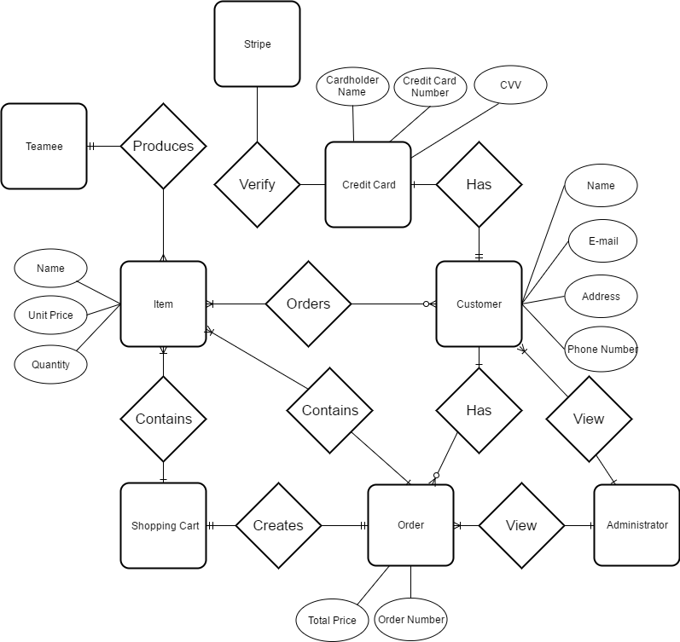

Figure 5: Entity Relationship Diagram

The ERD shows the relationship between entities within the Teamee system in the database.

## 6.1 Design constraints

DC-1 The system shall use Model-View-Controller

DC-2 The system shall use the Laravel framework

## 7.0 Software system attributes

### 7.1 Reliability

RE-1 The website shall be functional when being accessed

RE-2 Website shall not crash while user is accessing it

### 7.2 Availability

AVA-1 The Teamee web app shall be available 99% of the time every day except for maintenance windows. Maintenance window shall be within the time of 12AM-2AM local time.

### 7.3 Security

Only users with the correct authorization are allowed access.

### 7.4 Maintainability

MAIN-1 The code will be well documented

MAIN-2 Documents shall be updated when changes are made.

## 8.0 Use Case

## 8.1 Use Case Descriptions

|  |  |
| --- | --- |
| **Primary Actor** | **Use Cases** |
| User | UC-1 Register for account  UC-2 Add item to cart  UC-3 Checkout items  UC-4 Search for the closest location  UC-5 View all locations  UC-6 Contact Teamee  UC-7 Sign up for promotions and news  UC-8 View user’s order  UC-9 View website  UC-10 View all items sold by Teamee |
| Administrator | UC-11 Check all orders  UC-12 View all subscribers  UC-13 View user’s contact information |

Figure 6: List of Use Cases

|  |  |
| --- | --- |
| **ID and Name:** | **UC-1 Register for account** |
| Primary Actor: | User |
| Description: | The user shall register for an account on Teamee by clicking of the Register link. The user must enter his/her email information, username, and password to register. |
| Trigger: | User accessed Teamee’s website and clicked on the Register link to register for an account. |
| Preconditions: | PRE-1 User must have a valid email address  PRE-2 Username must be available  PRE-3 Password must be at least 6 characters long |
| Postconditions: | POST-1 Teamee shall send a verification email to the user’s email  POST-2 The user shall click on the verification link in the email  POST-3 The user’s information shall be stored in the Teamee’s database |
| Normal Flow: | 1. Register for an Account 2. User click on the Register link on the Teamee web app 3. User enter a valid email address 4. User enter a username that is available 5. User enter a password that is at least 6 characters long 6. User click submit button 7. System shall display a confirmation screen that tell the user to check his/her email for verification |
| Alternative Flow: | 1.1 Sign-in to a Registered Account  1. User with an existing account shall sign into his/her account  2. User sign in using his/her email with the correct password |
| Exceptions: | E1 Invalid email address  E2 User name is taken  E3 Password is not long enough  E4 Password does not match confirm password |
| Priority: | High |
| Frequency of Use: | Dozens of users a day. |
| Other Information | N/A |
| Assumptions: | AS-1 User have an email address  AS-2 Peak usage when web app first become available |
|  |  |
| **ID and Name:** | **UC-2 Add Item to Cart** |
| Primary Actor: | User |
| Description: | The user can browser drinks and products sold by Teamee and select products to be added to his/her shopping cart. |
| Trigger: | User accessed Teamee’s website and clicked on the Menu link located in the navigation bar. In the Menu page, the user can click on a product and click on the Add to Cart button. |
| Preconditions: | PRE-1 User must be in the Menu page |
| Postconditions: | POST-1 Item is added to chart |
| Normal Flow: | 1. Add Item to Cart 2. User click Add to Cart button 3. Item is added to cart 4. Number of items in cart is updated |
| Alternative Flow: | 2.1 Item is Unavailable  1. An alert will display if the user attempts to add an item that is unavailable to cart  2. Item is not added into the cart |
| Exceptions: | N/A |
| Priority: | High |
| Frequency of Use: | Hundreds of instances per day |
| Other Information | N/A |
| Assumptions: | AS-1 User have internet connection to access the Menu page |

|  |  |
| --- | --- |
| **ID and Name:** | **UC-3 Checkout Items** |
| Primary Actor: | User |
| Description: | Checkout items allow the user to place an order. |
| Trigger: | User clicked on the shopping cart and proceeded to checkout. |
| Preconditions: | PRE-1 User must have a valid email address  PRE-2 User must provide a shipping and billing address  PRE-3 User must provide payment information such as credit card information |
| Postconditions: | POST-1 Teamee shall send an order confirmation to the user’s dashboard  POST-2 User’s order is stored into Teamee’s database  POST-3 Administrator shall be able to view the user’s order |
| Normal Flow: | 1. Checkout Items 2. User enters in email address, shipping, billing, and payment information 3. User click submit button 4. Teamee system verifies payment information 5. Teamee system stores user’s order |
| Alternative Flow: | None |
| Exceptions: | E1 Invalid email address, payment, shipping, or billing information  E2 If user is not logged in.   1. System shall redirect user to the user login page 2. User log in 3. Continue normal flow 3 |
| Priority: | Normal |
| Frequency of Use: | hundreds of users a day. |
| Other Information | Users need an account in order to checkout. |
| Assumptions: | AS-1 User have an email address, billing, shipping, and payment information  AS-2 Higher than normal usage during the weekend |

|  |  |
| --- | --- |
| **ID and Name:** | **UC-4 Search for the closest location** |
| Primary Actor: | User |
| Description: | The user shall be able to search for the closest location to himself. |
| Trigger: | User clicked on the search icon. |
| Preconditions: | PRE-1 User must be in the location page  PRE-2 User must provide an address or zip code |
| Postconditions: | POST-1 A popup window will show the closest location to the user. |
| Normal Flow: | 1. Search for the closest location 2. User type in a zip code or address in the search bar 3. An autofill will display based on the user’s input 4. User clicks on the search icon 5. System shall display a popup window of the closest location to the address or zip code inputted |
| Alternative Flow: | N/A |
| Exceptions: | E1 Invalid address or zip code |
| Priority: | Normal |
| Frequency of Use: | hundreds of users a day. |
| Other Information | N/A |
| Assumptions: | AS-1 User have an address or zip code to input |

|  |  |
| --- | --- |
| **ID and Name:** | **UC-5 View all locations** |
| Primary Actor: | User |
| Description: | Users shall be able to view all the locations of Teamee on a map. |
| Trigger: | User clicked on the location link. |
| Preconditions: | PRE-1 User must have clicked on the location link. |
| Postconditions: | POST-1 A map with markers shall display all of Teamee’s locations. |
| Normal Flow: | 1. View all locations 2. User clicks on the location link 3. A map is generated using Google map API 4. Markers displayed all of Teamee’s location 5. Users can click on a location marker and a information window shall be displayed |
| Alternative Flow: | N/A |
| Exceptions: | N/A |
| Priority: | Normal |
| Frequency of Use: | hundreds of users a day. |
| Other Information | Map is zoomed in to show all locations when page is loaded |
| Assumptions: | AS-1 There are at least 1 Teamee location |

|  |  |
| --- | --- |
| **ID and Name:** | **UC-6 Contact Teamee** |
| Primary Actor: | User |
| Description: | Users can contact Teamee by clicking on the contact link and filling out the contact form. |
| Trigger: | User clicked the submit button |
| Preconditions: | PRE-1 User must fill out all the required fields |
| Postconditions: | POST-1 An email is sent to [info@Teamee.com](mailto:info@Teamee.com) with the user’s input message and contact information |
| Normal Flow: | 1. Contact Teamee through contact form on the website 2. User clicked on the contact link 3. User fill out the contact form 4. User clicked on the submit button 5. A success or error message is displayed 6. An email is sent to the [info@Teamee.com](mailto:info@Teamee.com) with the message from the user |
| Alternative Flow: | N/A |
| Exceptions: | E1 [info@Teamee.com](mailto:info@Teamee.com) inbox is full  E2 User did not fill out all the required fields |
| Priority: | Normal |
| Frequency of Use: | hundreds of users a day. |
| Other Information | Users do not need to have an account to contact Teamee |
| Assumptions: | AS-1 User have an email address |

|  |  |
| --- | --- |
| **ID and Name:** | **UC-7 Sign up for promotions and news** |
| Primary Actor: | User |
| Description: | Users can sign up to receive news and promotions from Teamee by entering in their email address. |
| Trigger: | User typed in his email address and clicked the submit button |
| Preconditions: | PRE-1 User must have an email address |
| Postconditions: | POST-1 Teamee shall store the user’s email address in the database |
| Normal Flow: | 1. Sign up for promotions and news 2. User type in his email address 3. User clicked submit button 4. The user’s email address is stored within the Teamee’s database |
| Alternative Flow: | N/A |
| Exceptions: | E1 Invalid email address |
| Priority: | Normal |
| Frequency of Use: | dozens of users a day. |
| Other Information | Users do not need to have an account to sign up for promotions and news |
| Assumptions: | AS-1 User have an email address |

|  |  |
| --- | --- |
| **ID and Name:** | **UC-8 View order** |
| Primary Actor: | User |
| Description: | After the user placed an order, the user shall be able to view the order in his user’s dashboard. |
| Trigger: | User clicked on Place Order button and Stripe has cleared the payment. |
| Preconditions: | PRE-1 User must have a valid email address  PRE-2 Stripe cleared the payment |
| Postconditions: | POST-1 All the user’s orders shall be displayed in the user’ |
| Normal Flow: | 1. View order 2. The user logs in 3. System shall redirect the user to the user’s dashboard 4. System shall display all orders made by the user |
| Alternative Flow: | N/A |
| Exceptions: | E1 Invalid login credentials  E2 Payment did not clear |
| Priority: | Normal |
| Frequency of Use: | hundreds of users a day. |
| Other Information | The order shall be displayed with the order date, all items in the order, the price of each item, and the total price. |
| Assumptions: | AS-1 User have an email address  AS-2 User’s inbox is not full  AS-3 User’s payment successfully cleared |

|  |  |
| --- | --- |
| **ID and Name:** | **UC-9 View website** |
| Primary Actor: | User |
| Description: | The user shall be able to view all the web pages from Teamee |
| Trigger: | User enters in Teamee url |
| Preconditions: | PRE-1 User must have a browser open  PRE-2 User must enter in Teamee url |
| Postconditions: | POST-1 Teamee website shall be displayed |
| Normal Flow: | 1. View website 2. User opens website browser 3. User enters in Teamee url 4. System shall display the Teamee homepage |
| Alternative Flow: | N/A |
| Exceptions: | E1 Invalid URL |
| Priority: | High |
| Frequency of Use: | hundreds of users a day. |
| Other Information | Web pages:   1. Homepage 2. Contact 3. About Us 4. Location |
| Assumptions: | AS-1 User is connected to the internet  AS-2 User have a compatible web browser |

|  |  |
| --- | --- |
| **ID and Name:** | **UC-10 View all items sold by Teamee** |
| Primary Actor: | User |
| Description: | The user shall be able to view all items sold by Teamee. |
| Trigger: | User clicked on a menu item in the nav bar. |
| Preconditions: | PRE-1 User must have an internet browser open  PRE-2 User must have an internet connection |
| Postconditions: | POST-1 Teamee shall display the items that are sold by Teamee |
| Normal Flow: | 10.0 View all items sold by Teamee   1. User click on a menu item 2. System shall display all the menu items sold by Teamee |
| Alternative Flow: | N/A |
| Exceptions: | N/A |
| Priority: | Normal |
| Frequency of Use: | hundreds of users a day. |
| Other Information | The user shall be able to click on each menu item and view a more detailed description of each menu item. |
| Assumptions: | AS-1 User is connected to the internet  AS-2 Teamee have items to display |

|  |  |
| --- | --- |
| **ID and Name:** | **UC-11 Check All Orders** |
| Primary Actor: | Administrator |
| Description: | The Administrator can check all orders made by the users. Orders are separated by pending, completed and future orders. |
| Trigger: | Administrator logged into her account. |
| Preconditions: | PRE-1 Administrator must be logged in |
| Postconditions: | POST-1 Administrator can edit orders  POST-2 Teamee system shall save an edits made by the administrator |
| Normal Flow: | 11.0 Check All Orders   1. Administrator’s portal open to the Orders page 2. Orders are displayed with newest orders on top 3. Administrator can search through orders 4. Teamee system saves any changes made to orders |
| Alternative Flow: | N/A |
| Exceptions: | E1 Order was deleted from the system |
| Priority: | Normal |
| Frequency of Use: | Daily when the store is open |
| Other Information | Each store has 1 administrator account |
| Assumptions: | AS-1 Administrator account was set up |

|  |  |
| --- | --- |
| **ID and Name:** | **UC-12 View All Subscribers** |
| Primary Actor: | Administrator |
| Description: | When a user input their email into the subscription field and click subscribe, the information is stored into the database. The admin shall be able to view all users who had opted in for subscription. |
| Trigger: | Admin enters Admin dashboard. |
| Preconditions: | PRE-1 Administrator is logged into her account  PRE-2 There are subscribers |
| Postconditions: | POST-1 Admin dashboard shall display a table of subscribers |
| Normal Flow: | 12.0 View all subscribers  1. Admin log in  2. Subscribers are pulled from database and displayed |
| Alternative Flow: | N/A |
| Exceptions: | E1 No subscriptions exist |
| Priority: | Low |
| Frequency of Use: | Hundreds of uses per day |
| Other Information | N/A |
| Assumptions: | AS-1 Admin is logged in  AS-2 There are subscribers |

|  |  |
| --- | --- |
| **ID and Name:** | **UC-13 View user’s information** |
| Primary Actor: | Administrator |
| Description: | Admin can look for a user’s contact information such as name and phone number. |
| Trigger: | Admin is in the admin portal and clicked on view profile on a user’s name |
| Preconditions: | PRE-1 Admin must be logged in  PRE-2 User must exist |
| Postconditions: | POST-1 A table shall display the user’s contact information |
| Normal Flow: | 13.0 View user’s information   1. Admin logged in 2. Admin is directed to the admin dashboard where all users are displayed in a table |
| Alternative Flow: | N/A |
| Exceptions: | E1 User does not exist |
| Priority: | Normal |
| Frequency of Use: | Hundreds of times a day |
| Other Information | User’s contact information includes:   1. Name 2. Email |
| Assumptions: | AS-1 User had previously placed an order |

# 6.0 Software Design Document

## 1.0 INTRODUCTION

### 1.1 Purpose

This software design document describes the architecture and system design of the Teamee web application.

### 1.2 Scope

This document will focus on the GUI of the Teamee application. It will also contain designs of the website’s software architecture.

### 1.3 Overview

This Design Document will contain a:

1. Purpose
2. Scope
3. Reference
4. System Overview
5. System Architecture
6. Data Design
7. Component Design
8. Appendix

### 1.4 Reference Material

Wiegers, Karl, *Software Requirements (3rd Edition* ), Microsoft Press 2013.

## 2.0 SYSTEM OVERVIEW

The framework that shall be used is Laravel 5.4. Laravel is a PHP framework that contains its own template and supports PHP directly in its pages.

Front End Framework

1. Materialize
2. Bootstrap
3. Animate.css

## 3.0 SYSTEM ARCHITECTURE

### 3.1 Architectural Design



Figure 7: Swimline diagram

The swimline diagram showed a flow when a customer began to place an order on the website. This diagram helps shows the entities that are involved and the activities that take place. The flow began when customers placed items into a chart, they can then go to checkout. During checkout, customers are asked for some personal information such as name, billing address, and credit card information. The information is transferred to Stripe, a company that helps in the billing process. After Stripe verified that the credit card is valid and payment is processed, the order go to the store selected. Employees at the store received the order and fulfill the order. The order is hold until the customer come to the store and picks up the order.

### 3.2 Decomposition Description



Figure 8: DFD for placing an order

The data flow diagram shows the flow of data when a customer placed an order. This diagram should be used in conjunction with Figure 1. The DFD shows a more detailed view of all the data that occur during an order placement.

### 3.3 Design Rationale

#### 3.3.1 Trade Study

|  |  |  |
| --- | --- | --- |
| Quality Attribute | MySQL | MongoDB |
| Performance | 7 | 7 |
| Ease of Use | 6 | 9 |
| Compatibility | 10 | 2 |
| Supportability | 8 | 5 |
| Scalable | 6 | 9 |
| Reliability | 8 | 5 |
| **Total** | 45 | 37 |

Figure 9: A chart of a trade study done to determine which type of DBMS to use.

MySQL and MongoDB were both assigned a 7 for performance since they are about equal because this project is relatively small; thus, it is not expected that there would be huge stores of data. For ease of use, MongoDB was assigned a higher value because it uses dynamic schemas so that it is unnecessary to first define the structure when creating records. Also, one can simply change the structure of records by deleting and adding new fields to the existing ones. MySQL was given a significantly higher rating for compatibility because MySQL is supported by Laravel. In addition, MySQL is better suited as a ecommerce website because it can handle transactions exceptionally well compared to MongoDB. For supportability, MySQL received a higher rating than MongoDB because MySQL is an older and more established DBMS. As a result, it will have more documentations and skilled experts to provide additional assistance. Both DBMS are scalable; however, it is easier to scale using MongoDB. MySQL was given a higher rating for reliability than MongDB because can use ACID which stands for atomicity, consistency, isolation, and durability. These are the four properties of database transactions which are satisfied by MySQL.

### 3.4 System Context Diagram

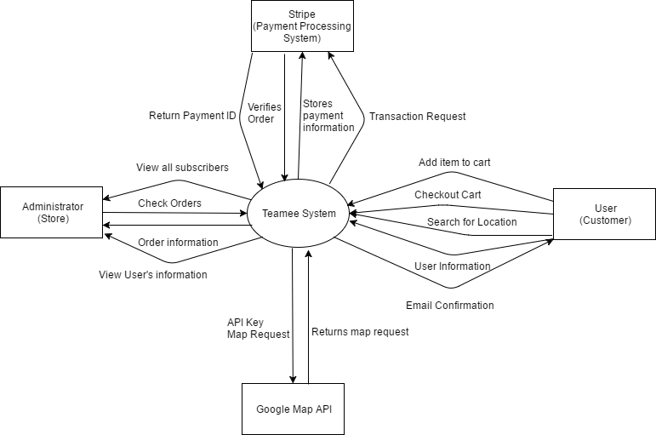

Figure 10 System Context diagram used to understand the interactions of various entities with the Teamee system

## 4.0 DATA DESIGN

### 4.1 Data Description

MySQL shall be used as the database.

### 4.2 Data Dictionary

|  |  |  |  |
| --- | --- | --- | --- |
| **Data Element** | **Description** | **Composition/Data Type** | **Length** |
| First Name | The user’s first name | String | 50 |
| Last Name | The user’s last name | String | 50 |
| User’s email address | The user’s email address | String | 50 |
| Order number | Auto incremental order number for each order placed by the user | Primary key  Integer | 10000000 |
| Item Number | Each item sold by Teamee is assigned an item number | Integer | 1000 |
| Payment Method |  | Alphabetic | 16 |
| Transaction Number |  | Integer | 12 |

Figure 11 data dictionary

## 5.0 COMPONENT DESIGN

### 5.1 Login Pseudocode

header.php  
check for cookie  
if exist set control panel with options and logout  
if none exist check session,  
if exist set control panel with options,  
if none exist  
exit

Ask for login and password with remember option (will set cookie)  
user inputs details, database check to see if user exists  
if exist register session and setcookie if remember option true  
else  
show signup so user can register

## 6.0 HUMAN INTERFACE DESIGN

### 6.1 Overview of User Interface

The user interface for the system will allow the user to easily place and order and view information about Teamee.

### 6.2 Screen Images



Figure 12: Mockup of the homepage

## 7. QUALITY ATTRIBUTES

## 7.1 Quality Attribute Scenarios

# 7.0 Test Plan

**An Online Shopping Website - Teamee**

Test Plan

## 7.1 Summary

The test plan outlined below is created for the Teamee online shopping website. This website is used to allow Teamee users to place an order and pay online to pick up their items instore. The online payment and ordering allow users to bypass the line and wait to obtain their order at their convenience. In addition, the objective of this web app is to provide users with more detailed information about the company and its products. Users also have the opportunity to sign up for email subscription in order to obtain promotions that the company may release in the future. The objective of this test plan is to test the usability and functionality of the Teamee web app which includes all CRUD operations to ensure a smooth and secure user experience.

The main approach that shall be used include both manual and automatic testing. These tests shall be performed after each sprint and included in the testing phase of the sprint. Automated tools such as Selenium which was used to perform UI automation testing. The majority of testing shall occur through manual testing of the web app. Errors produced shall be addressed promptly when possible. If a major error occurred, a task shall be created and placed on the product backlog to be addressed in the next sprint.

A pass and fail criteria shall be included in the test plan along with the testing environment to ensure that results are reproducible.

The test plan shall be executed by one test engineer with knowledge of HTML5, CSS, JavaScript, and PHP. Also, this test engineer shall have knowledge of Laravel which is PHP framework used to create this web application. The approximate time-line for this test plain is 2 months which includes sometime during the development process. Since scrum is used as the developmental process, testing is done in conjunction with development.

## 7.2 Background

The Teamee web app is an ecommerce project aim to make ordering easy for users. Users can place orders and can view a history of all their orders. The app shall help admin and users keep track of the orders. Users can only view their orders while the admin can view all the orders placed by all users. Also, the admin can have a list of all the users registered in the application and all subscribers that had signed up for subscription to the newsletter.

## 7.3 Motivation

The motivation for this project stems from that fact that digital marketing is a huge factor in the success of a business. The web app can act as a marketing ploy by providing users with a means to access information about the company. In addition, the company can post promotions and send promotions to subscribed users. The company can also use data entered by users to mine data to improve services and products offered by the company.

Another motivator is the ability to expand the company’s influence. By allowing users to place order on the web application, users that are too busy to get in line and wait for their drinks to be made can take advantage of the convenience of the web app.

## 7.4 Objectives

The objective of the Teamee’s web app is to provide users with the means to shop Teamee’s products anywhere they can access a browser with internet connection. Users can reliably buy Teamee’s products with secure checkout and payment. The goal is to create an attractive and easy to use UI that will draw users to try and learn more about Teamee’s products. The test plan is used to guarantee that the application works as expected and fulfill all the functionality listed within the SRS document. Moreover, the test plan is produced to outline all the test cases and testing functionalities that will be executed throughout the developmental and testing phases while using Scrum. The ultimate goal is to use the test plan to reduce the amount of bugs that are produced by the web app.

## 7.5 System Requirements

The subsequent list provides an overview of all the major system requirements of the Teamee’s web application.

**SR-1 Adding item to cart**

The Teamee app shall allow the user to add an item into the cart. All items displayed in the products page shall have a button that allow the user to click on it to add to cart. The cart shall be updated with the item’s quantity as the user adds more items.

**SR-2 View items in cart**

The Teamee app shall allow the user to click on the cart icon located in the nav bar to access the cart page. The cart shall contain all the items that the users had added to the cart. If there are no items in the cart, a message shall display to inform the user that there are no items in the cart. The cart shall display the item’s name, quantity, unit price, and total price of the cart.

**SR-3 Removing an item from cart**

The Teamee app shall allow the user to remove an item from the cart. A dropdown button is located next to each item, where the user can click and choose to remove one quantity of the item. The cart shall then be updated to show the correct quantity and total price. If there was only one item in the cart, then the item shall be completely removed from the cart.

**SR-4 Removing all items from cart**

The Teamee app shall allow the user to remove all items of the same kind from the cart. The user can click on the remove dropdown button to select remove all and all quantities of the selected item shall be removed from the cart.

**SR-5 Checkout items in cart**

The Teamee app shall allow the user to checkout a cart. The user must be logged in to checkout a cart. The app shall check that the billing information which includes: cardholder name, credit card, CVC, and credit card’s expiration date are valid using Stripe API.

**SR-6 Search for nearest location**

The Teamee app shall allow the user to input an address or location and show the closest Teamee store. An info-window popup shall be displayed on the Google map with information about the closest store such as the store’s: address and phone number.

**SR-7 View all locations**

The Teamee app shall allow the user to view all the current Teamee’s store locations displayed on a Google map. Each location is marked with a pin drop. The user can click on the pin to open an info-window that shows more details about the store such as the address and phone number of the store.

**SR-8 User can view his order**

The Teamee app shall allow the user to view his order. The user shall only be allowed to view orders that he had placed, but not anyone else’s. All previous orders are shown in the user’s dashboard which is only accessible if the user had logged in.

**SR-9 Admin view all user’s order**

The Teamee app shall allow the admin to view all orders made by all users. Each order shall show the user’s name, order date, user’s phone number, items sold, and total price of the order. This information is only accessible if the admin was logged in, under an admin account.

**SR-10 Submit email for newsletter subscription**

The Teamee app shall allow users to sign up for a newsletter or promotional subscription by entering in their email address. The input field’s description should be apparent where users can immediately recognize that the input is asking for an email address. When the user clicks on the subscribe button, the user’s email address shall be stored in the database. Only the admin can have access to all the subscribers.

**SR-11 Access security**

The Teamee app shall restrict certain types of users from accessing certain pages. Users can only view their profile page and not any other users profile page. Information posted in the user’s profile page should pertain to that user. Admin’s dashboard can only be accessed through an admin account. The admin can view information about the users, but not their password. Users must be logged in to proceed to checkout and place an order.

**SR-12 Database reliability**

The Teamee’s database should be reliable with backups set in placed. The database should constantly be running. If shutdown is necessary for any reason, a backup database should be used.

**SR-13 Database security**

The Teamee app’s database shall be secure and protected from hackers. Valuable data should be encrypted and secure inside the database.

**SR-14 Hardware and software constraints**

The Teamee app can be ran on various browsers such as Firefox, Chrome, Microsoft Edge, and Safari. In addition, the Teamee app shall also work on browsers using mobile phones. The website shall be responsive on laptops, computers, and mobile phones.

**SR-15 Contact form sent to correct email**

The Teamee app shall allow the users to fill out a contact form and send it to Teamee. The users must fill out the email, message, and name section.

## 7.6 Requirements to be Tested

Not all requirements can be tested due to time constraint and limited resources. Therefore, only a select number of requirements shall be tested. These requirements were chosen based upon their critical roles within the Teamee app. The selected requirements were determined to have the highest effect to the values that were deemed most essential to the success of the app which are usability and reliability. The requirements to be tested should help fulfill all the use cases. The use cases are:

UC-1 Register for account

UC-2 Add item to cart

UC-3 Checkout items

UC-4 Search for the closest location

UC-5 View all locations

UC-6 Contact Teamee

UC-7 Sign up for promotions and news

UC-8 View user’s order

UC-9 View website

UC-10 View all items sold by Teamee

### 7.6.1 System Requirements to be Tested

|  |  |
| --- | --- |
| **Use Cases** | **System Requirements** |
| UC-1 Register for account | SR-11 Access security |
| UC-2 Add item to cart | SR-1 Adding item to cart |
| UC-3 Checkout items | SR-5 Checkout items in cart |
| UC-4 Search for the closest location | SR-6 Search for nearest location |
| UC-5 View all locations | SR-7 View all locations |
| UC-6 Contact Teamee | SR-15 Contact form sent to correct email |
| UC-7 Sign up for promotions and news | SR-10 Submit email for newsletter subscription |
| UC-8 View user’s order | SR-8 User can view his order  SR-11 Access security |
| UC-9 View website | SR-12 Database reliability |
| UC-10 View all items sold by Teamee | SR-12 Database reliability |
| UC-11 Check all orders | SR-11 Access security |
| UC-12 View all subscribers | SR-11 Access security |
| UC-13 View user’s contact information | SR-11 Access security |

Figure 13: table of the use cases mapped to the system requirements

### 7.6.2 System Requirements Not Tested

Some system requirements that were not tested because they were not deemed as valuable or at high risk as other system requirements.

**SR-13 Database Security** was not tested because most user information is not extremely sensitive. The only user data that are stored in the database are the user’s name, address, and phone number. Extremely sensitive data such as credit card number and other payment information are not stored within Teamee app’s database, they are only passed through Stripe. Therefore, database security was not considered a paramount system requirement to be tested.

## 7.7 Approach

Testing shall occur at the end of each sprint. Both manual and automated testing shall be used. All testing shall be recorded and well documented. Moreover, both white box and black box testing shall be performed.

White box testing shall be used by utilizing phpunit an integrated testing tool provided within the Laravel framework. Phpunit shall be used to perform unit, integration, and regression testing. Using phpunit is convenient since it is supported and already included with Laravel. The use of phpunit is less consuming since installation is already supported. However, to keep testing data separate from development, a unique database is created called teamee_testing to store all testing data. This database shall only be used for testing purposes and is referenced within the phpunit xml file.

Black box testing shall mainly be used to test the UI. Selenium IDE is installed in Firefox and shall be used as the UI automation tool. Selenium IDE includes a UI recording tool that mimics a user browsing through the website. This tool is extremely valuable for regression testing.

## 7.8 Staff

This is a small project that only contain a single developer. Therefore, testing is also done by the same developer. The tester has had experienced with using the Laravel framework. However, this is the first time that she had used phpunit within Laravel to develop unit tests. The tester does have experience using Selenium IDE before to perform UI automated testing. Therefore, UI testing shall be a quick and smooth experience. The tester shall be trained to write unit tests for the unit testing using phpunit. Tests results shall be recorded and documented by the tester.

## 7.9 Record Keeping

All tests logs shall be kept in the tests folder. Because phpunit is integrated in Laravel, there is a tests folder located within the Teamee folder. Unit test scripts are stored within this folder and tests folder. Screenshots of each tests that are ran shall be kept for record and stored within a testing screenshot folder. Records of testing are also kept in this document at the end of each sprint.

## 7.10 Testing Tools

As mentioned before, the two main testing tools that shall be used are Selenium IDE for black box testing and phpunit for white box testing. These tools were chosen based upon their usefulness, learning curve, and cost. In addition, the tester shall use tools available in the browsers such as Chrome developer tools and Firefox firebug for testing. These browser tools are an invaluable source during development and can be used to detect performance speed and error logs.

## 7.11 Types of System Testing

This section will outline some system tests that shall be executed. Each section shall provide details about how each system test shall be performed. Usability and regression testing are used for functional testing. These tests will help promote a better user experience by reducing the number of bugs that the user may encounter. Usability was chosen because it is an important nonfunctional requirement that would affect the user’s experience. Websites that are intuitive to use where navigation is not complex encourages longer use of the website. Regression testing was chosen because it can ensure that there are few to no bugs introduced as the project is being developed.

### 7.11.1 Usability Testing

The purpose of usability test is to ensure that the design allow the business functions to be used as easily and intuitively as possible. To perform usability testing, it is necessary that the tester understand who the users of the systems are, the business needs, and to mimic the user’s behavior. Selenium IDE is a suitable tool to achieve these goals. Selenium IDE can record and mimic a user’s behavior by testing the UI. Also, it can be easily set up and executed each time during acceptance testing at the end of each sprint.

### 7.11.2 Regression Testing

Regression testing is used to verify that all previous functionalities are still working correctly. Regression testing ensures that the changes made in the current sprint did not affect functions in the previous sprints in an unexpected and unpredictable way. Selenium IDE can also be used for regression testing because it recorded and saved the tests done in previous sprint. So, Selenium can be re-ran if nothing in the UI had changed. However, the majority of regression testing shall be carried out by phpunit. Phpunit allow unit tests to be ran within the Laravel framework. These unit tests can be used to verify that previous functions are still working as anticipated.

## 7.13 Test Deliverables

This section lists all the test deliverables that shall be generated during the testing process. The following shall be included:

1. System Test Plan
2. Test case documents
3. Test scripts
4. Test log
5. System Test Results
6. Test Summary Report

## 7.14 Testing Environment

### 7.14.1 Hardware Requirements

The hardware used to run these tests is a Lenovo Thinkpad laptop running Windows 10. The laptop has access to the internet.

### 7.14.2 Software Tool Requirements

Software that are needed for testing are: Xampp, Laravel, and internet browsers such as Chrome, Firefox, and Microsoft Edge. All browsers are updated with the newest version. The Laravel used for development and testing is also the most current Laravel, which is Laravel 5.4. Xampp was used as a web server and MySQL was used as the database.

## 7.15 Staffing and Training Needs

There is only one dedicated test engineer for this project. The tester is familiar with using Atom as the code editor and Selenium IDE. However, training is needed to use phpunit with Laravel. In addition, the tester need to become familiarized with writing unit tests. Even though, phpunit came installed with Laravel, there are still some setups that need to be configured. Thus, there is still a strong learning curve to use phpunit to create unit tests.

## 7.16 Test Schedule

The following table shows the tasks and estimated time that it would take to complete each task. These tasks are crucial to the success of the testing process. Since there is only one tester, all responsibilities are assigned to the sole tester. The lowest denomination of the estimated time is one day. Unit, system, and acceptance testing are expected to take 6 weeks because that is the total length of all the sprints. Testing is done after each sprint; therefore, the length of testing matches the development process since Scrum was used.

|  |  |
| --- | --- |
| **Tasks** | **Estimated Time** |
| Create Test Plan | 4 Days |
| Install testing tools | 1 Day |
| Create Testing Database | 1 Day |
| Unit Testing | 6 weeks |
| System Testing | 6 weeks |
| Acceptance Testing | 6 weeks |
| Test reports and summary | 3 Days |

Figure 14: test schedule

# 8.0 Development

## 8.1 Iteration 1

### 8.1.1 Sprint Planning

During the sprint planning for the first iteration, a set of use cases were selected and moved to the “Working On” section. These cases were chosen based upon their high risk and priority. View website was chosen because a basic UI layout was needed in order for the users to use the website. View all locations and Search for the closest location was chosen because they were deemed at a high risk due to my unfamiliarity with using Google map API. Register for an account was also chosen because it would be one of the first function that a new user would utilize. The figure below showed the backlog for Iteration 1 with the five use cases to be implemented.

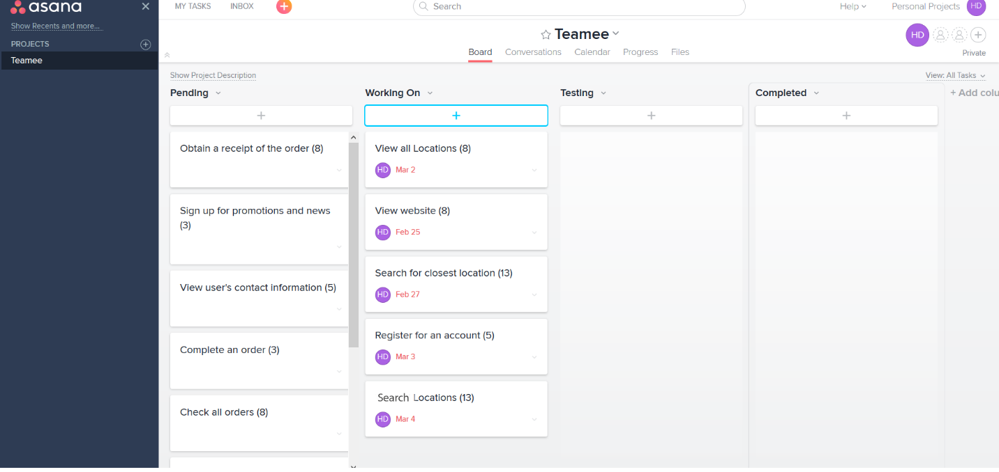

Figure 15: Sprint backlog for iteration 1 using Asana board feature

The four figures below showed screenshots of what the website currently looks like after Iteration 1.

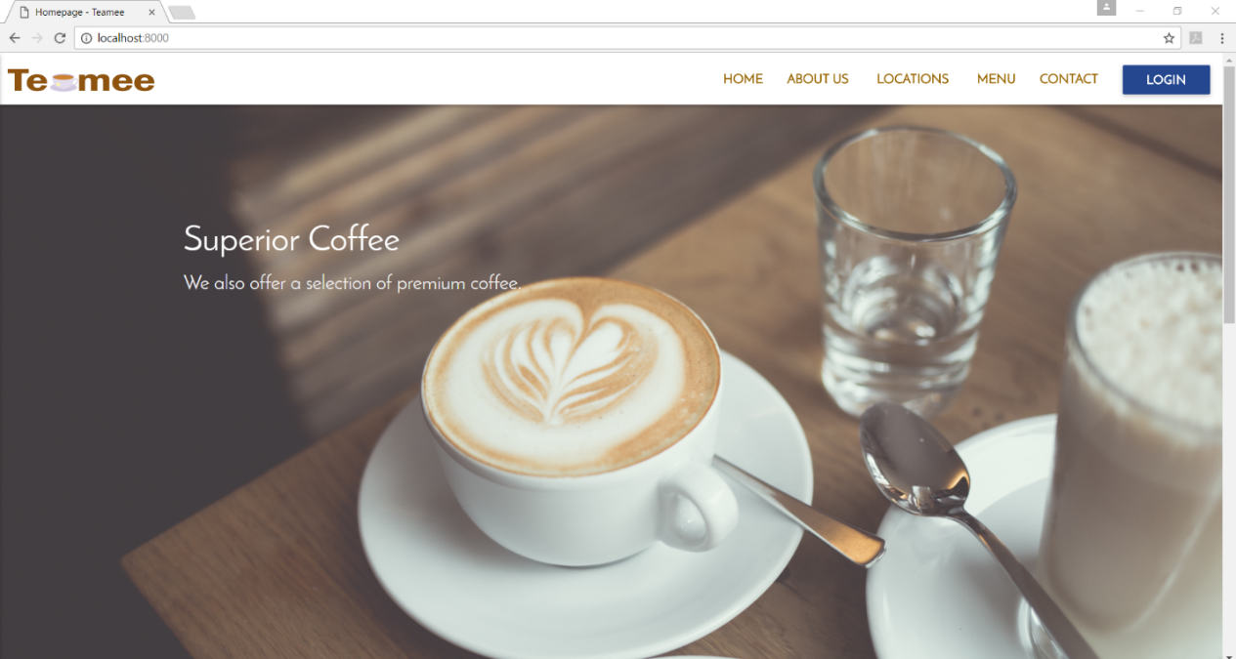

Figure 16 screenshot of the Teamee homepage

The current homepage has a large carousel on top with a video in the middle of the page. A footer is in each page. The carousel auto rotates through six different images. When the user clicks on the Teamee logo, the user is directed back to the homepage. The homepage is available to the public and any user can access the homepage.

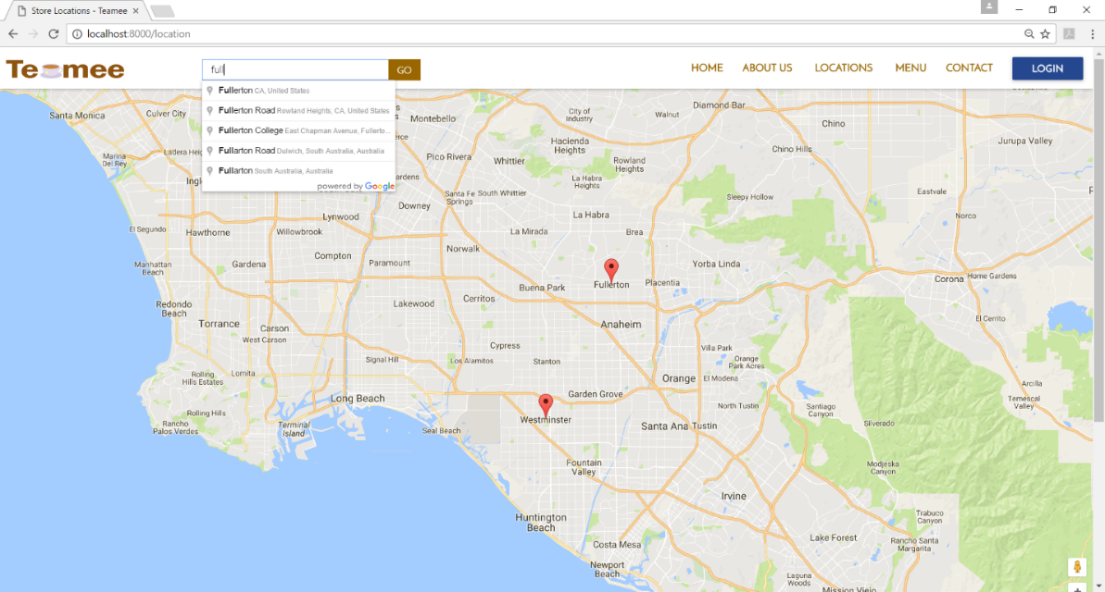

Figure 17 screenshot of the locations page with the two Teamee stores on Google map

The map shown uses Google map API. The search bar on top of the page can autofill in as the user types a location or address. Two red pins denote where the Teamee stores are on the map. Users can zoom in or out, the map is set to load where both stores are visible and centered. This will allow the users to easily see all Teamee’s store locations.

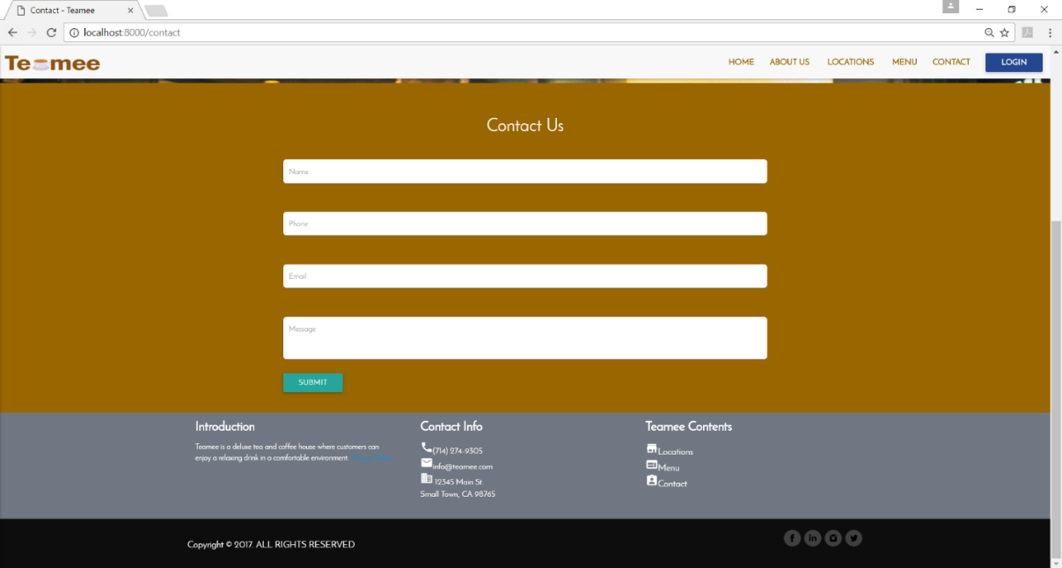

Figure 18: Screenshot of the contact page

The contact page is a simple form that only requires the user to input their name, email, phone number, and message. All of these fields are required and the system shall display an error if any of these fields are left blank. Currently, the layout of this contact page is completed, but the backend is not implemented. If the user clicks the submit button now, no action will occur. The form was created using Materialized CSS instead of Bootstrap.

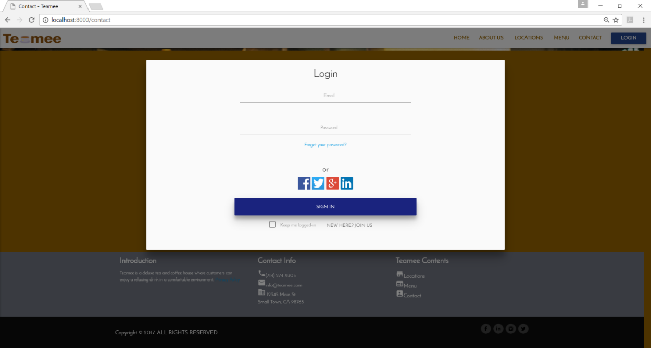

Figure 19 shows a modal for users to login

The modal was created using Materialized CSS. The user can open the modal by clicking the login button located on the navigation bar. This is just a layout so it is not functional yet. The login modal is a simple format requiring the user’s email and password to login. There are social medial login icons and a remember me checkbox.

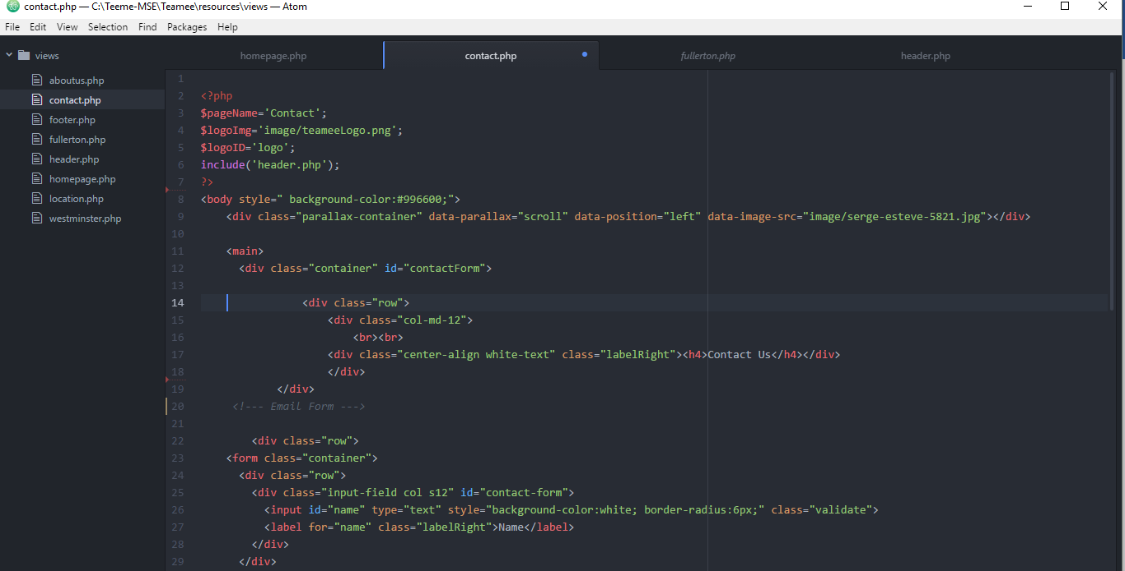

Figure 20: contact page code

Figure 18 shows a snippet code sample of the contact page. Atom was used as the code editor. On the left-hand side, there’s a quick link to the various pages that are within the views folder. The contact page is just a simple PHP file. Blade template was not used yet in Iteration 1.

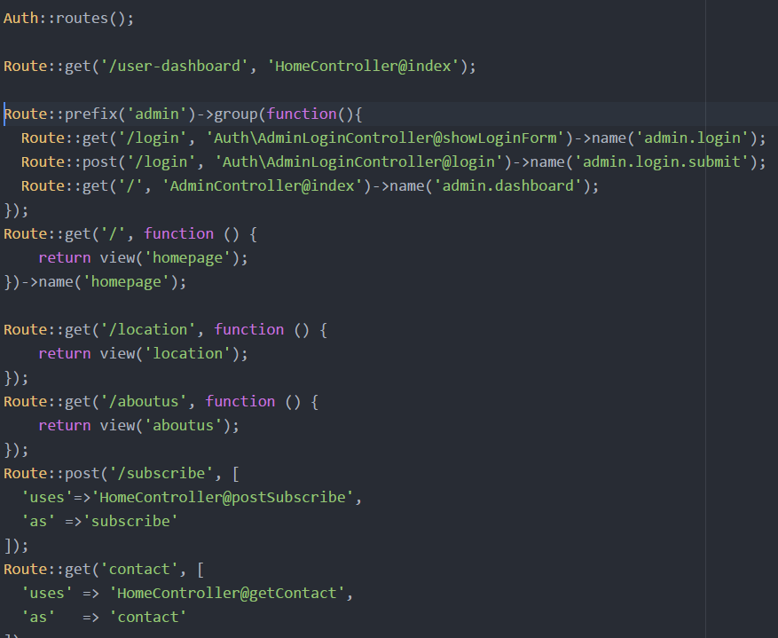

Figure 21: Code showing some routes that were set up

The web routes were set up for all Teamee’s web pages. Laravel allow the developer to set a name for each route; however, naming is optional so only some routes were named. The screenshot above showed the routes for the login pages for the admin, home, location, about us, and contact page. Some of these routes point to the controller where it calls a class for an action to occur then the view is returned. However, the home, about us, and location pages only contain informational contents. Therefore, a simple route where a view is returned was sufficient. For pages that require an action or class to be called, the route points to the controller where the view of the page is returned at the end.

### 8.1.2 Testing

**UI Testing**

First, the UI was tested manually to see if all the pages show up as expected when the url is typed in. Then Selenium IDE was used to record and mimic a user’s interaction with the UI. The picture below showed that one test was ran and it resulted in a pass.

Manual UI Test Results:

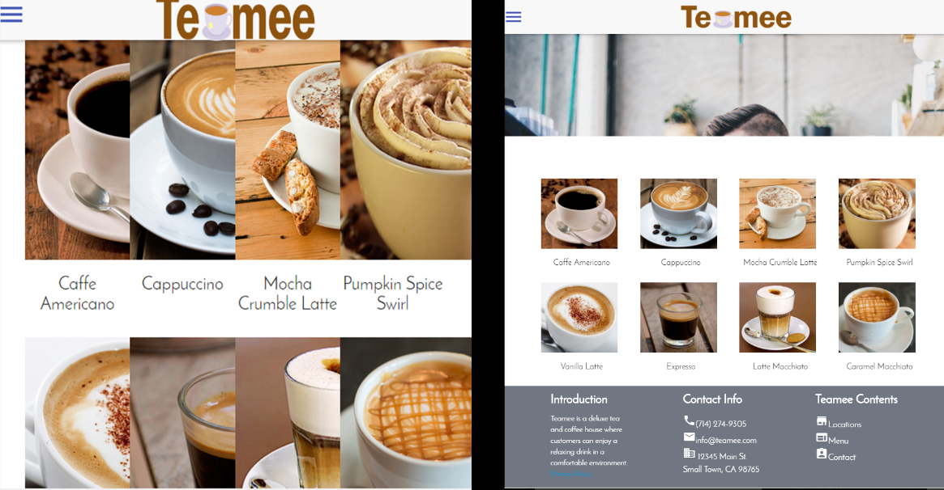

Figure 22: Shows the responsiveness of the menu page layout.

The image on the left showed that the items listed were not responsive once the screen size is reduced. The image on the right showed that the page was fixed and the images are responsive. The layout should be user friendly even when view on a mobile device. As the screen size decreases, the number of items shown in a row also decreases. In a small mobile device, only a single item is shown at a time.

Automated UI Test Results:

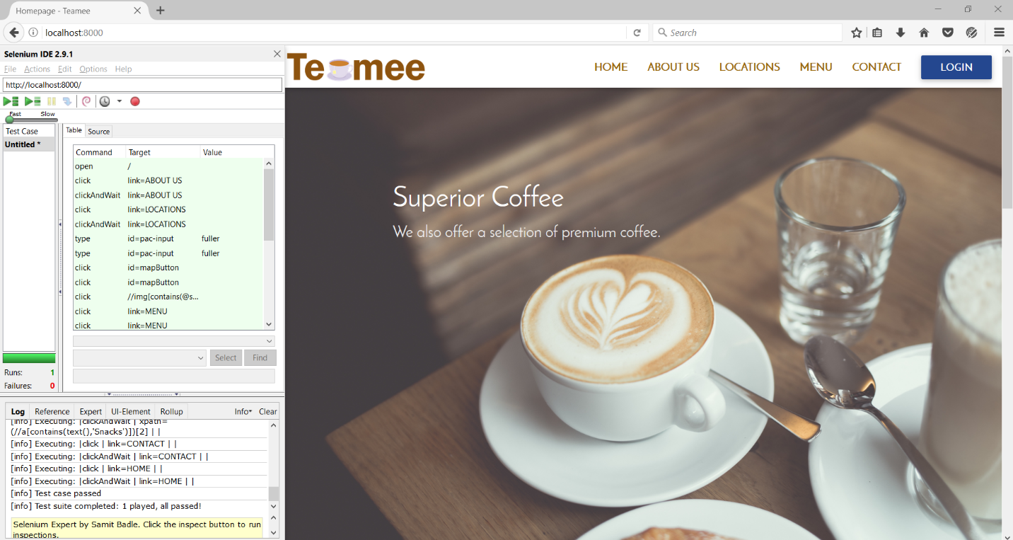

Figure 23: The homepage with Selenium IDE opened, showing one successfully completed test.

The simulated path started with opening the home page then the user click on each page to guarantee that each page contained contents and that they opened to the correct pages. Moreover, this test verified that the links are directing to the correct routes.

**Performance Testing**

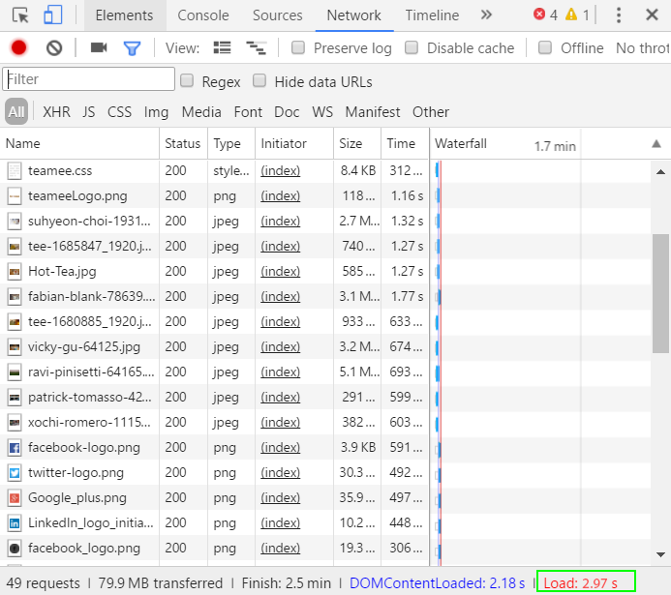

Figure 24: Loading speed is boxed in green tested using Chrome’s developer tools for the homepage.

This test was conducted using Chrome’s developer tool. The load speed for the homepage is 2.97 seconds. The loading speed for the homepage passes the performance requirement set in the SRS. It was stated in the SRS that the loading speed of the homepage should not exceed 7 seconds. The homepage was chosen as a benchmark because all users who accessed the Teamee web app shall first see the homepage. The homepage is the most important page within a website.

**Functional Testing**

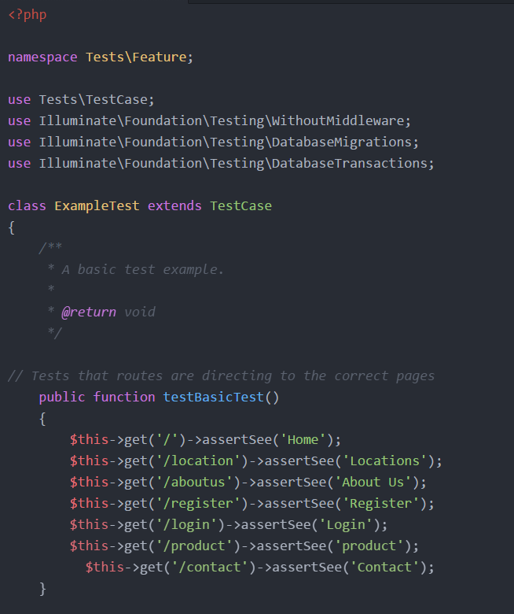

Figure 25: Code showing testing conducted using phpunit to test features of the web app.

This code is available in the tests folder within the Teamee app folder. This is a basic test written to test that the routes are working correctly. Phpunit was used to run the test.

### 8.1.3 Sprint Review

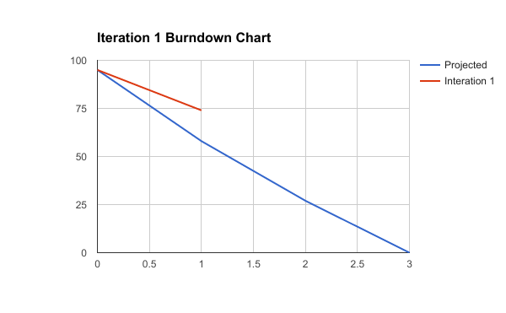

Figure 26: Burndown chart for Iteration 1

|  |  |  |  |
| --- | --- | --- | --- |
| **Name** | **Description** | **Acceptance Criteria** | **Story Points** |
| Register for an Account | As the user, I want to be able to sign up for an account on Teamee. | Page is created, with route and controller set up. | 5 |
| View all locations | As the user, I want to find where all Teamee stores are on a map. | Page is created, with pins showing locations of stores on the map. | 8 |
| Search for closest location | As the user, I want to find the closest store to the location that I specified. | User input an address in search bar and closest store is displayed. | 13 |
| Contact Teamee | As the user, I want to be able to contact Teamee for comments or questions. | Page is created with the contact form. When user submit form, the form is emailed to Teamee. | 3 |
| View Website | As the user, I want to be able to access and view all pages from Teamee. | Basic layouts of all pages are created. Routes for all pages are set. | 8 |

Figure 27: Table showing the tasks that were chosen for Iteration 1. Green highlight signified the completion of the task.

The table above showed the product backlog for Iteration 1, each task was matched with its user story and story points with an acceptance criteria listed. When a task has fulfilled the acceptance criteria, it is considered done. However, tasks that were only partially completed are not highlighted. Therefore, the rows highlighted in green are considered done since the acceptance criteria was met.

In this first Iteration, three out of five product backlog items were deemed completed. Two tasks were not completed because there were some issues that arose which prevented them from being considered completely fulfilled. Search for closest location was not fulfilled because the info-window was not opening. When the user inputs an address, and click the search button, the user is moved to the store pin and an info-window pops open to inform the user that this store is the closest store. The google map loaded with the two pins designated the Teamee stores, but the info-window does not open. Debugging this issue took longer than expected; so, it was decided that this bug would be moved to the next Iteration.

It was not anticipated that the contact page would create any issue because I have had experienced making numerous contact pages before using PHP. However, this whole project is hosted locally so I had to configure the mailer. Also, by using Laravel blade, I can’t directly code PHP into the page. Therefore, the contact page did not work as expected and had to be moved to the next Iteration.

Due to the unforeseen issues, only 21 story points were completed during this Iteration. For Iteration 2 there will be more tasks and story points added to the product backlog.

### 8.1.4 Retrospective Meeting

There were more issues and bugs that arose during this Iteration than was expected. This Iteration has shown that time estimation needs to be improved. To improve, I need to consider not only if I have had experience implementing something, but also the different conditions and environment that is present. For example, I thought that implementing the contact page would be a simple task. However, since I don’t have access to a live server like Bluehost, which was what I was used to having for actual production websites. I had trouble getting the contact form to work on localhost.

However, this first Iteration has taught me many things about Laravel that I had not known about before. I’ve worked with Laravel in the past, but by creating this web app by myself, I’ve discovered more features that I had not known about before. In the past, when working in a team, certain decisions were already made, but by building this web app from scratch by myself, I’ve learned much more.

One of the most important thing that I’ve learned about Laravel was the blade template. Blade is a unique templating engine offered by Laravel. To use the blade template, I just had to include a .blade to the name of the PHP file. Therefore, to take full advantage of all that Laravel has to offer, I intend to convert all of my PHP files to blade. This will add additional work to Iteration 2, but in the long run, using blade will reduce the time it’ll take to complete my web app.

## 8.2 Iteration 2

### 8.2.1 Spring Planning

The tasks for Iteration 2 has increased significantly due to the issues that were found in the first Iteration. Firstly, I planned to address all the bugs that were carried over from Iteration 1. Also, as mentioned in the Retrospective section, I wanted to convert my files to use the blade template offered by Laravel. Afterwards, I will continue with the use cases that were planned for Iteration 2.

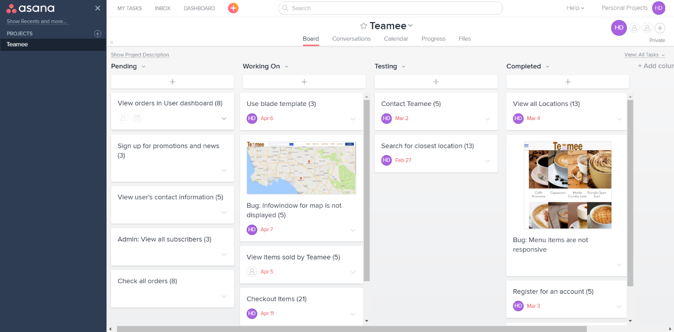

Figure 28: Sprint 2 Backlog hosted on Asana

The sprint backlog shows the Contact and Search for closest locations still in the Testing section because they were not finished due to some bugs and issues. Three tasks were moved from pending to the working on section following the timeline set in the Release Plan. An additional two tasks were added to the backlog as mentioned in the Retrospective meeting in Iteration 1. The two new tasks are fixing the info-window bug and changing all current PHP files to using the blade template.

To make a PHP file into a blade view file, I just have to change the files’ names to include the .blade.php file extension. However, I had to change the header file to use blade syntax. Direct PHP code doesn’t work within the blade view files.

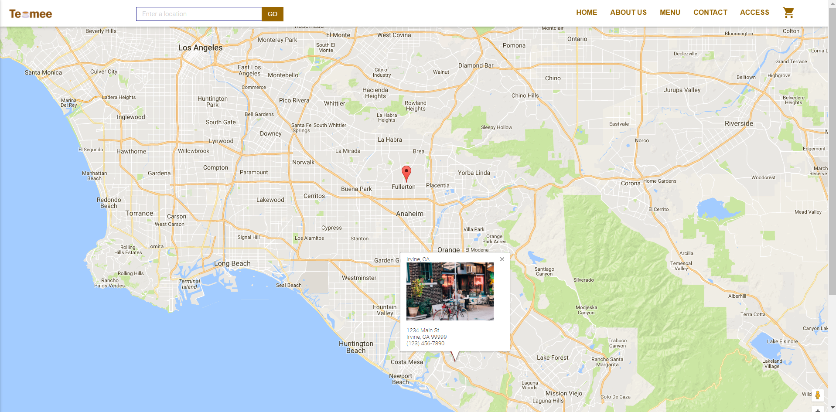

Figure 29: The map page showing the info-window working

The map page’s bug is fixed. The info-window will open if the user clicks on the pin. Also, when the user searches for the closest location, the closest store’s info-window will open to inform the user.

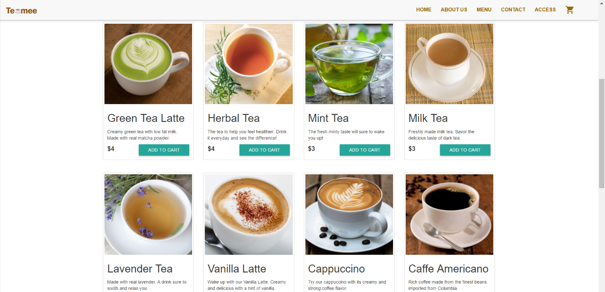

Figure 30: The remodeled menu page with all Teamee’s products

The menu page was redone to include each item’s name, description, price, and add to cart button. In the first Iteration, the menu page only had a picture and name of the items. Now, the page was updated to include more details about the items. The items are stored within the database in the products table. Each item have an id, title, description, price, and image path. The data is pulled from the database and populated for the user to see.

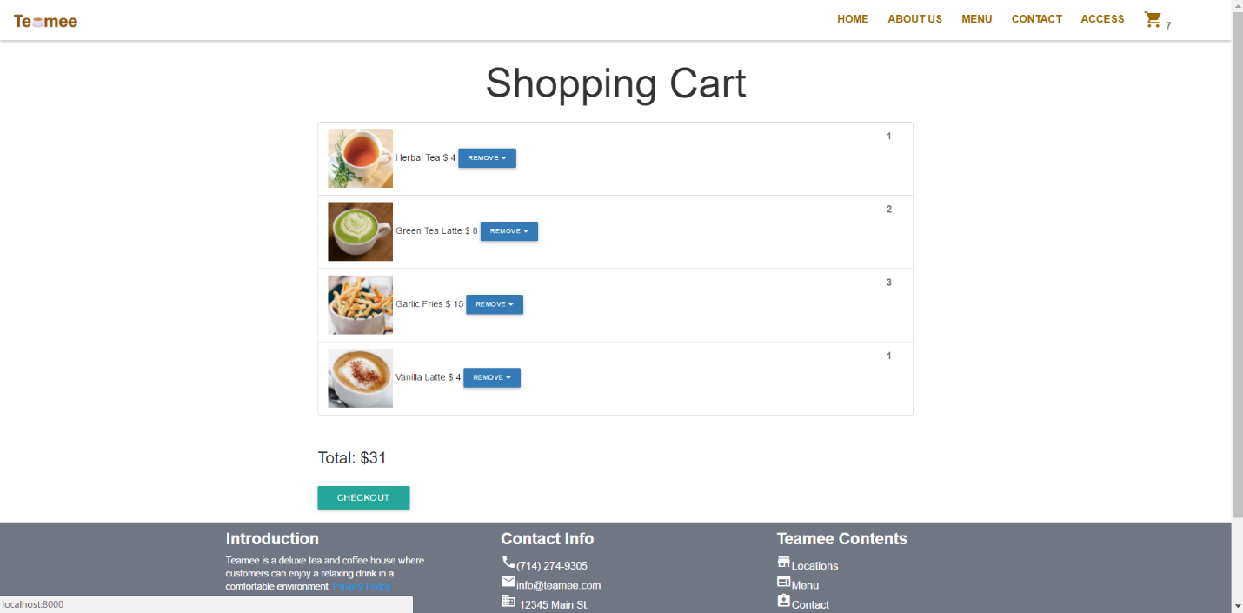

Figure 31: Shopping cart

This is a simple view of the shopping cart. The main points are all included which are the items added to cart, the item’s name, price, total price of the cart, and a button that allows the user to remove the items. The user is given two options for removal, the user can choose to remove one quantity or all quantities of an item. After the user had reviewed the shopping cart, the user can click on the checkout button to proceed to the checkout page.

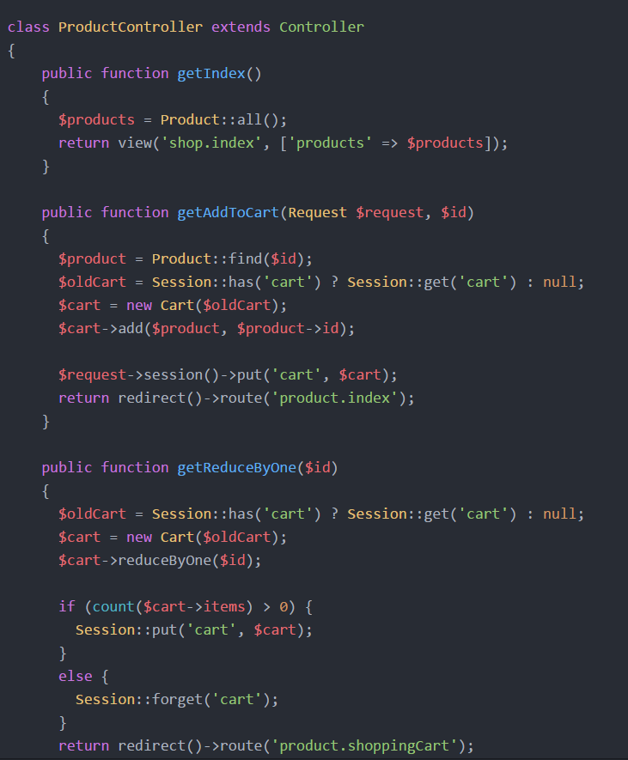

Figure 32: Code within the Product controller for adding and removing items from shopping cart

The above image shows a snippet of the code that allow the user to add items and remove items from the shopping cart. The names of each methods were created to be as self-explanatory as possible. The first thing listed is the method which ultimately returns a view of the shopping cart. The next method getAddToCart allow the user to add an item to cart by first using the item’s id to be stored in the cart. The method checks if there was a cart and if there is then store the cart in the variable oldCart, else set oldCart as null. Then a cart object is created and stored in the variable cart. The cart is updated to include the item that the user had added to cart. Finally, the getReduceByOne method is created to allow the user to remove one item from the shopping cart. Again, the method first checks if there is a shopping cart. Then remove an item based upon its id from the shopping cart. The if statement in this method is used to check if the quantity of the item was greater than 0, then the item shall still remain in the cart, else the item is removed from the cart because an item quantity that is 0 should not be in the cart.

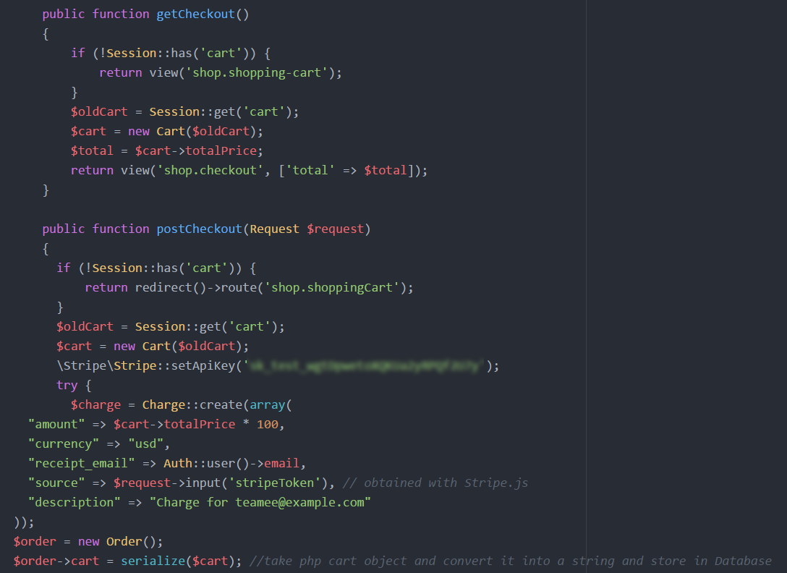

Figure 33: Code in the Product controller for checking out the shopping cart

The figure above showed the code for the user to checkout. The first method, getCheckout first checks if there is a cart, and if a cart does not exist then the user is taken to the shopping cart page. However, if there is a cart then the checkout page can be accessed with the total price displayed in the checkout page.

The postCheckout method is more complex and also started with checking if a cart existed. If a cart existed, then postCheckout method can proceed. In this method, the Stripe API is used to verify the user’s payment information. A Stripe API key is necessary and blurred out in the picture above for security purposes.

### 8.2.2 Testing

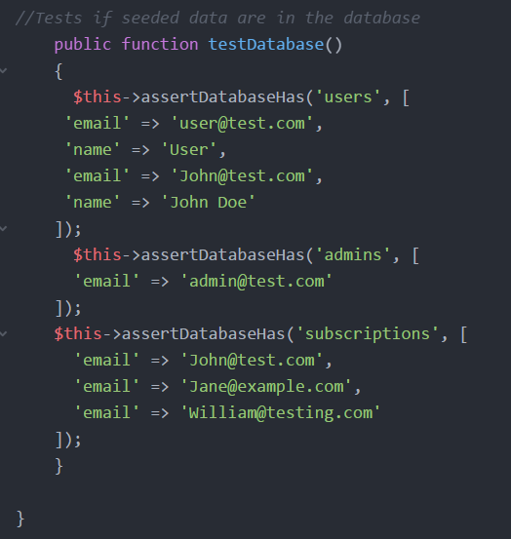

Figure 34: Code for testing the database

This test is used to ensure the reliability of the database. The test is written to check if the database contained all the data that was seeded to the database. The three tables that were tested were users and admins.

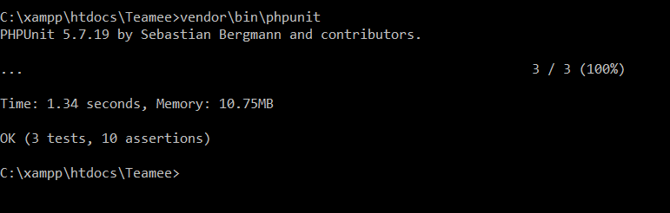

Figure 35: Image of Phpunit running

After writing all the test cases for this Iteration, phpunit was ran and the results were shown. The test was shown as a success with no errors displayed.

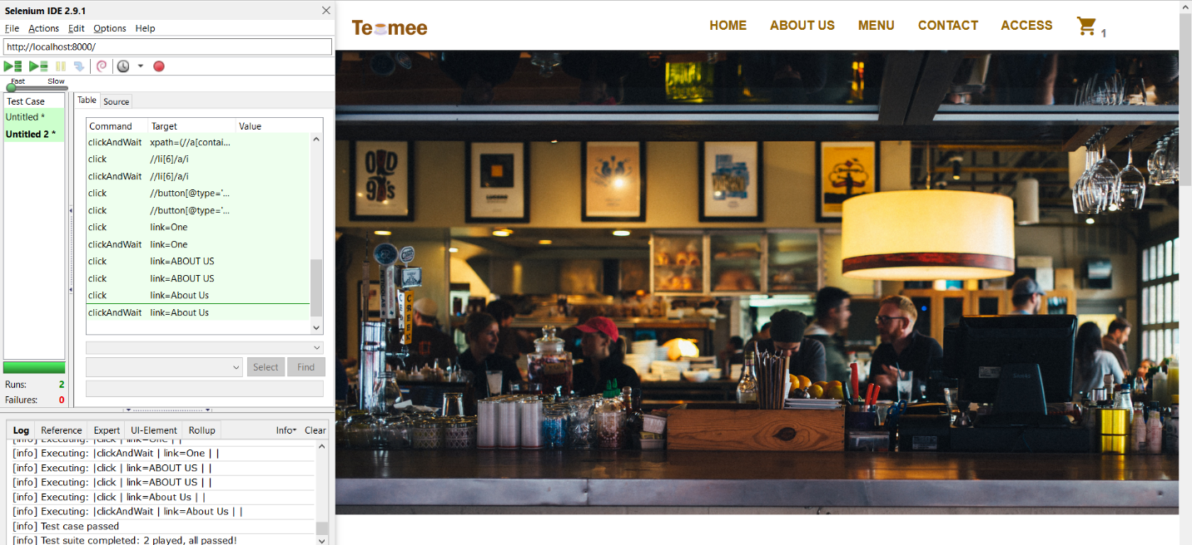

Figure 36: Selenium IDE test

Another Selenium IDE test was ran for this Iteration for automated UI testing. Selenium was used to ensure that the latest changes to the UI such as the nav bar with the cart icon and the updated menu page are working correctly.

### 8.2.3 Sprint Review

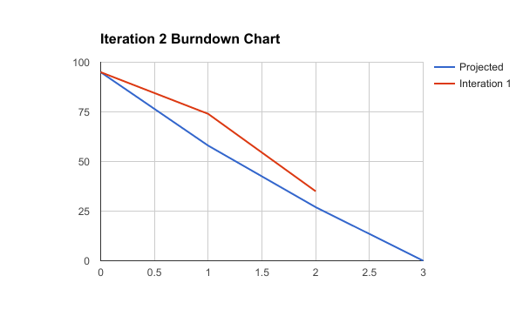

Figure 37: The burndown chart for Iteration 2

|  |  |  |  |
| --- | --- | --- | --- |
| **Name** | **Description** | **Acceptance Criteria** | **Story Point** |
| Use Blade Template | As a developer, I want to utilize Laravel’s blade template. | All links’ references are changed to match the new name extension. Blade template is working. | 3 |
| Bug: Info-window for map is not displayed | As the user, I want to view information about a store when I click on a pin. | Info-window opens when user clicks on a pin. Also, info-window should open when user perform a search to find the closest location. | 5 |
| View Items sold by Teamee | As the user, I want to view all Teamee’s items. | All items are displayed with its name, description, price, and add to cart button. | 5 |
| Checkout Items | As the user, I want to be able to checkout my shopping cart. | Users can input their information and payment information is set to Stripe to be verified. Then the checkout information is stored in the database as an order. | 21 |
| Add an item to cart | As the user, I want to be able to add an item to the shopping cart. | When the user clicks the add to cart button, the cart quantity is update, the item is available to be viewed in the shopping cart. | 5 |

Figure 38: Backlog table for Iteration 2. Green highlight signified the completion of the task.

This Iteration went more smoothly than the first Iteration. As shown in the table above, all tasks were highlighted in green which denoted that the tasks were considered completed. The first task that was completed was changing all the files name to include the blade extension so that the blade template can be used. The only small issue that occurred during this step was that all links had to be updated to include the blade extension. Fortunately, all the routes within the controller and route page does not have to have blade explicitly listed because Laravel can detect that the file is using a blade template automatically. I wanted to start using blade because it is fantastic for reducing and simplifying the code that was written in the views. As a result, using blade template engine makes the code easier to maintain.

The info-window bug was fixed when the latitude and longitude coordinates were updated within the locations page. The menu page was created to include all items sold by Teamee. This approach was used so that all items are displayed collectively and users do not have to access various pages for certain items. In addition, the number of Teamee’s products that are sold is small; thus, it is not necessary to include a separate page for each category of items.

The add item to cart feature was successfully completed in this Iteration. This step also included a method to allow the user to remove an item from cart. Since the two functions are similar, it was not difficult to implement the remove item from cart feature. I’ve only allowed the user to add one item at a time to the cart due to time constraint. However, in the future, I would want to allow the user to specify a quantity to add more than one item at once to the cart.

The checkout task was the most complex to implement because this was the first time that I had ever made an ecommerce website from scratch instead of using a CMS. However, obtaining a Stripe key was easy and the documentations on the Stripe’s website was extensively covered. There was a section especially devoted for PHP so integrating Stripe with Laravel was a painless procedure. However, after implementing this feature, I need to add another task to the next Iteration to force the user to log in before checking out the shopping cart. This will tie the user to the order that was created.

### 8.2.4 Retrospective Meeting

All tasks were successfully completed in this Iteration. Bugs from the first Iteration were also fixed. The Teamee ecommerce site is taking on better shape now with more backend implementations. Implementation became easier once I became more familiarized with using Laravel again. Also, the use of the blade template engine made implementation occur more smoothly.

However, there were still a task that needed to be added to Iteration 3’s backlog. While manually testing the website, I noticed that there was a bug when a user or admin is redirected. Admin must be logged in to view the admin dashboard. If a user types in the URL for the admin dashboard, she is redirected to the user’s login page. This is an incorrect flow, since if a person wants to access the admin dashboard, but is forced to login, then that person should be redirected to the admin login page.

Moreover, when a user first register for an account, the user should receive a welcome email automatically sent to their inbox. These two new tasks shall be added to the third Iteration.

## 8.3 Iteration 3

### 8.3.1 Sprint Planning

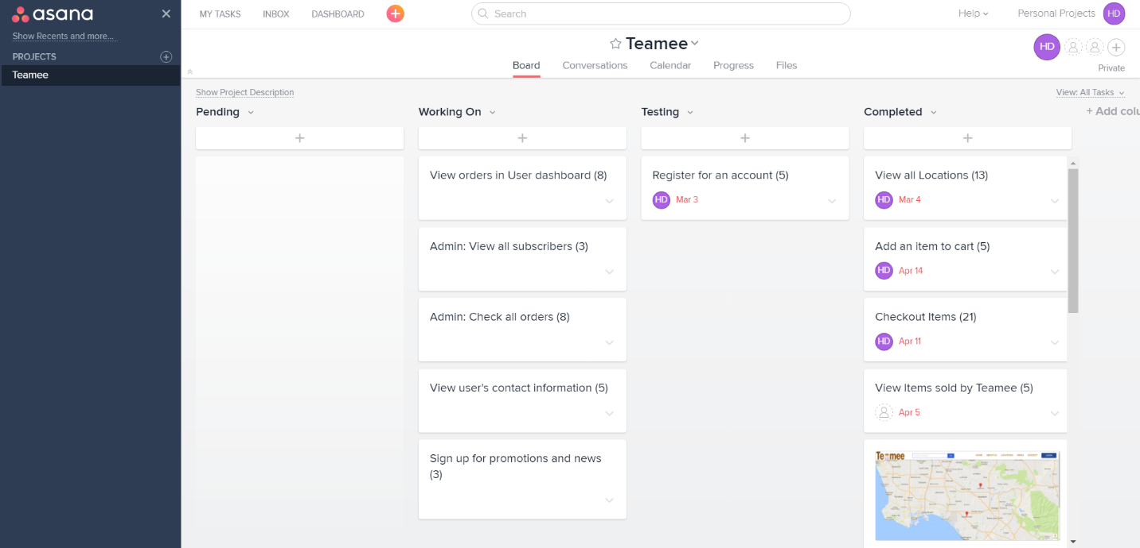

Figure 39: Sprint backlog for Iteration 3

In the last Iteration, all tasks in the Pending column were moved to the Working On column. There was a total of seven tasks to be implemented for this Iteration. The Register for an account task was left in the Testing section because I wanted to implement the feature that would have the system automatically send a new user a welcome email after registering for an account.

In addition, finalization of the web app occurred in this Iteration. Some layouts were modified to be more visually pleasing.

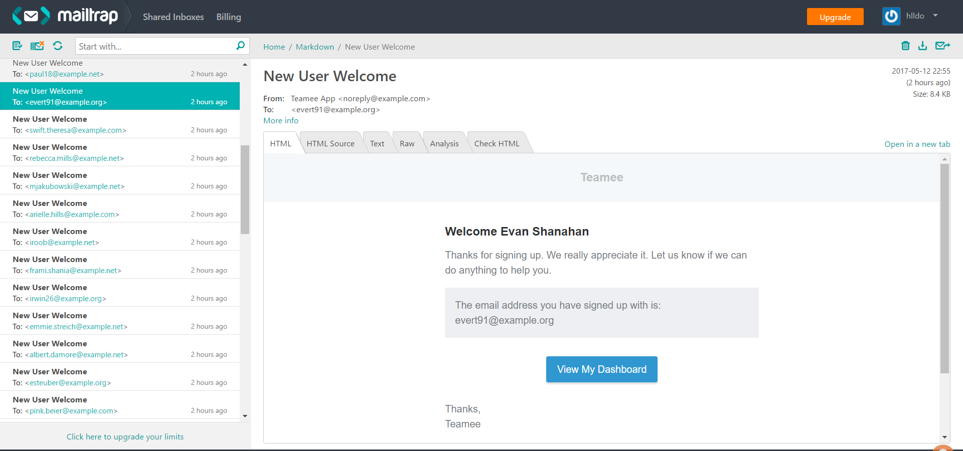

Figure 40: Mailtrap showing all emails sent and received from Teamee

This figure showed a screenshot of Teamee’s inbox using Mailtrap. Mailtrap collects all outgoing and incoming emails sent or received by Teamee. In this example, a new user called Evan Shanahan whom had successfully registered for an account at Teamee is receiving a welcome email. This feature was created using event and listener. The email view was created using the blade template engine which created an attractive email view for the user.

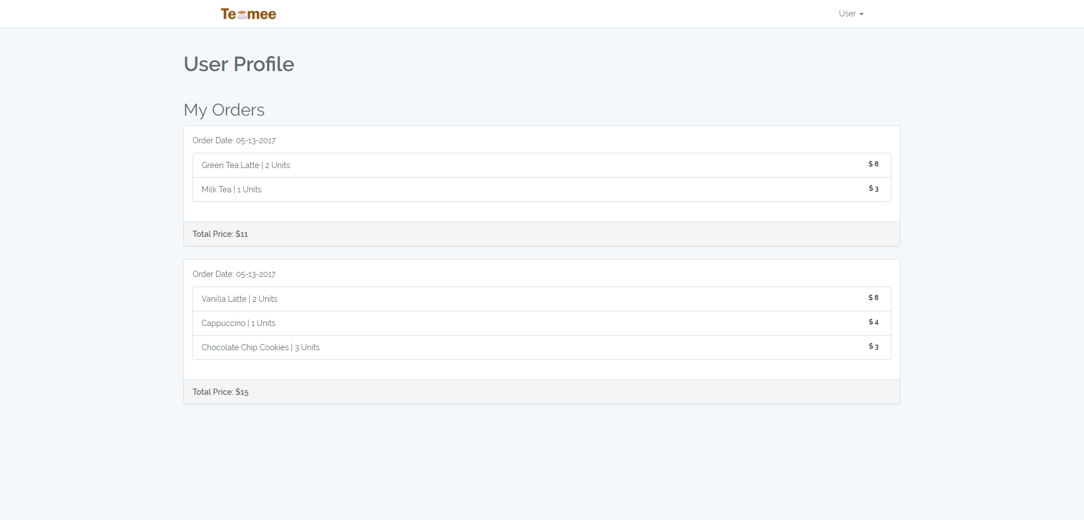

Figure 41: User’s page showing the user’s profile

The user’s profile page provides a simple view that just show all the user’s orders. The orders were pulled from the database and displayed for the user to see. The user can only see his orders and no other user’s orders.

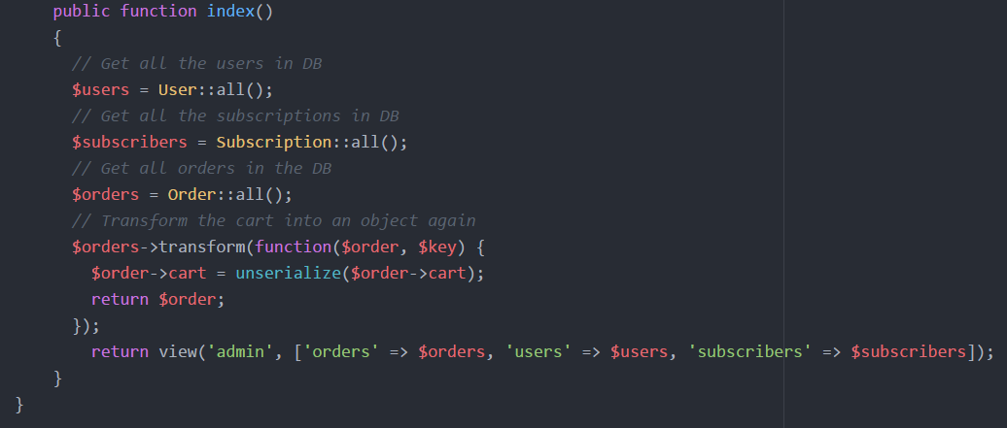

Figure 42: Code to view admin’s dashboard within the admin’s controller

The above figure shows a snippet of code within the admin’s controller for displaying the admin’s dashboard. The method began with pulling all users, subscriptions, and orders from the database. Both the user and subscriptions were already objects that could be used, but the order object contain the cart which was serialized in the Product controller. Therefore, it was necessary to un-serialize the cart and transform it back into an object. Then the view for the admin dashboard is returned.

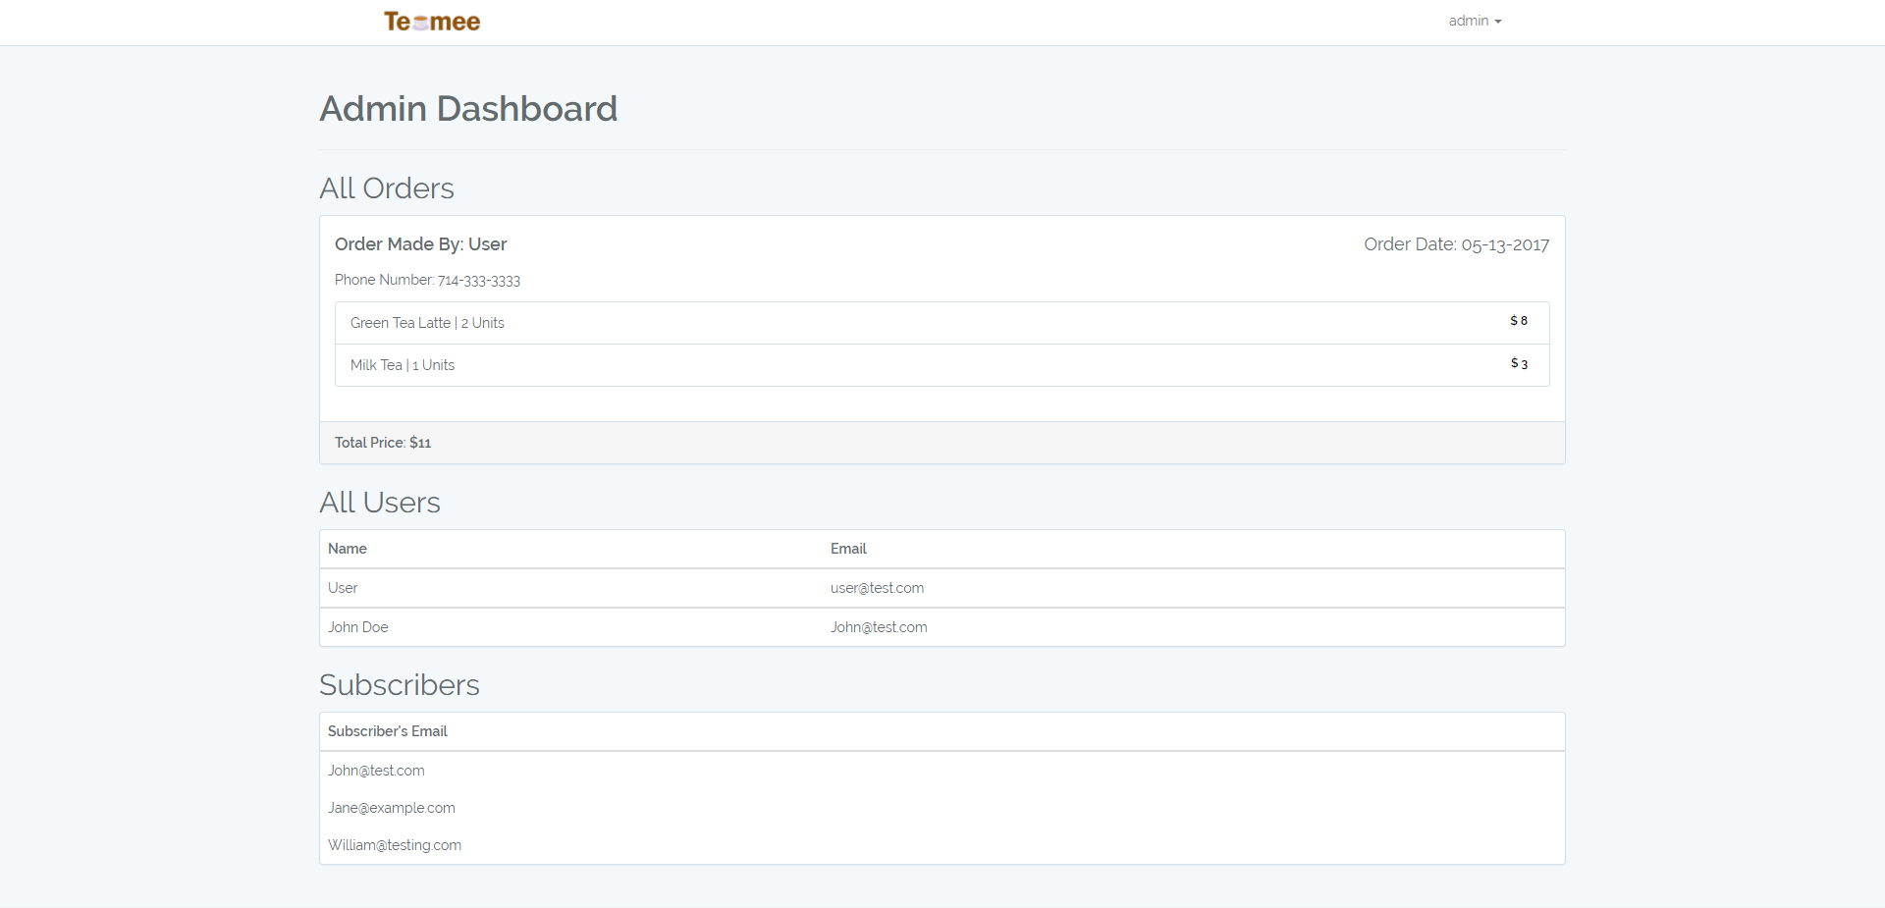

Figure 43: Admin’s page showing the admin’s dashboard

The admin page also uses the blade template engine to generate the view seen in the picture above. A loop was used to go through all the orders stored in the database and displayed under the orders section. The same process was used to display all the users and subscribers. Unlike the user’s profile page, the admin can view all orders made by any users.

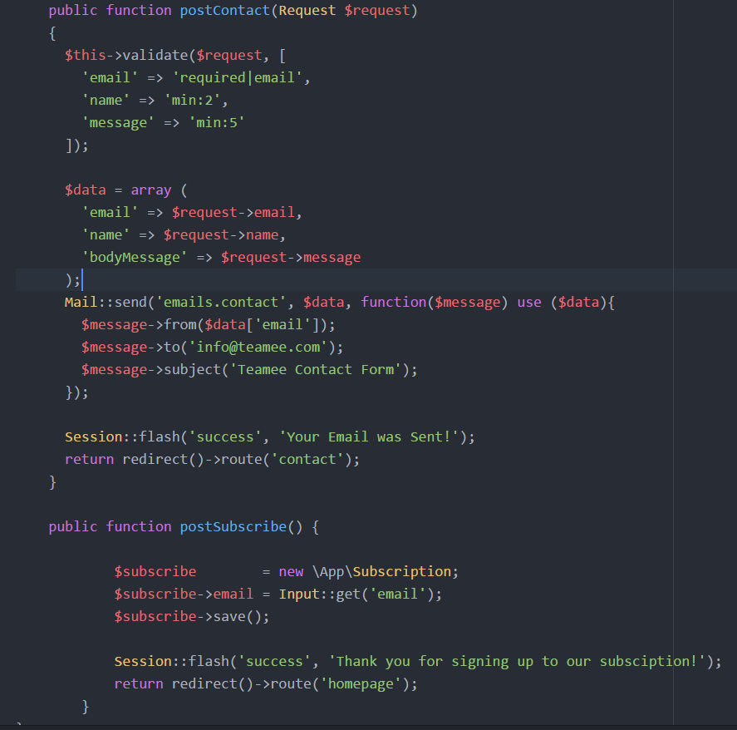

Figure 44: Code showing methods for contact and subscription

The above snippet of code shows how the back-end of the contact form and subscription features were implemented. When the user clicks the submit button in the contact form, the postContact method is called. So first, the input fields are validated to ensure that each field were filled out with a minimum length for certain fields. Then the input is stored in an array called data. The Mail façade is used to send the email to [info@teamee.com](mailto:info@teamee.com). Then the user is redirected back to the contact page with a success message.

In the postSubscribe method, an object called $subscribe is created. Then the user’s input is obtained from the form and stored in the email property of the $subscribe object. In the third line, the object is saved into the database. Then the homepage reloads with a success message.

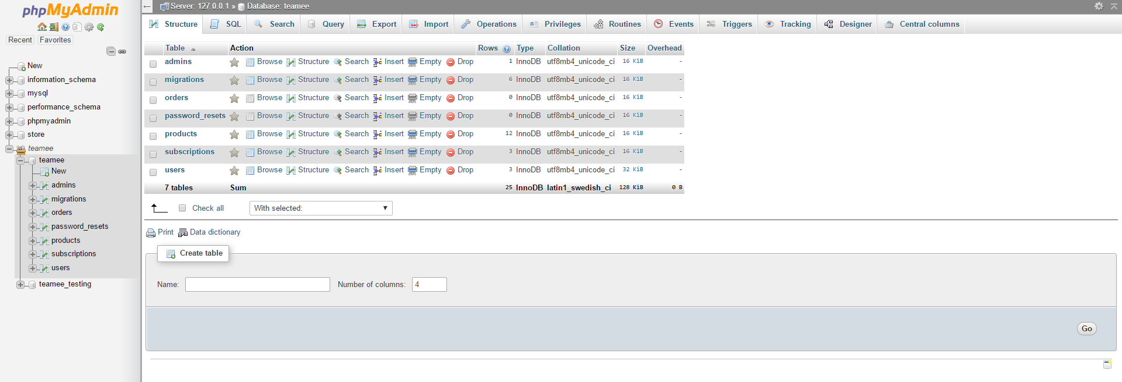

Figure 45: Teamee’s databases shown using phpMyAdmin

MySQL was used as the RDBMS for this project. On the left hand-side there are two databases created for the Teamee project. The first database called teamee was used for development. While, the teamee_testing database was used solely for testing purposes.

### 8.3.2 Testing

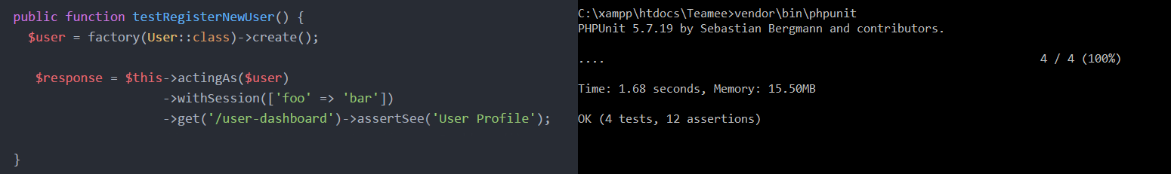

Figure 46: Test for creating a new user

This test was created to ensure that the access protection is working. The test began with using Laravel’s factory to create a user. Then the test uses the user that was created and test to see if the user could enter the user-dashboard and see the user’s profile page. The image to the right showed that phpunit was ran and resulted in a success.

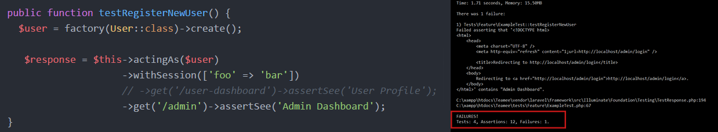

Figure 47: Test if user can enter admin page

This test was created using the same method, but instead of trying to get to the user-dashboard, it tries to access the admin’s page. The image to the right showed that phpunit was ran and resulted in a failure. This was expected because the user should not have had access to the admin page. Therefore, this test proved that the access protection is working properly and the tests are yielding the expected outcomes.

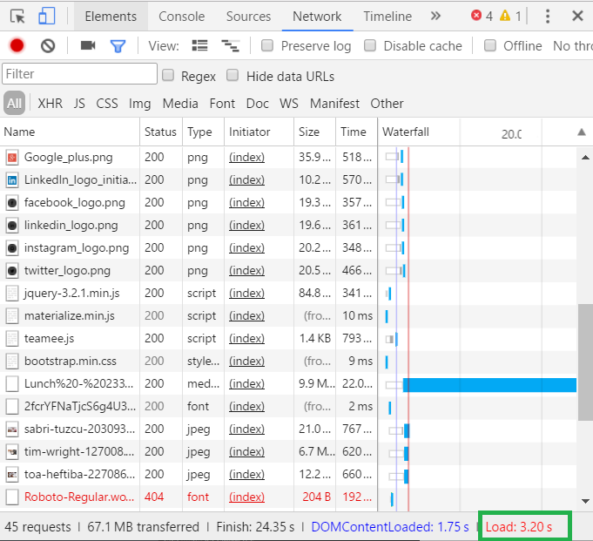

Figure 48: Loading speed of the homepage in Iteration 3

The loading speed of the homepage was ran again using Chrome’s developer’s tool to check the performance of the web app. The result is boxed in green and showed that the loading speed was 3.20 seconds. This loading speed is greater than the last one that was ran in Iteration 1. I decided to do because this is the final version of the Teamee web app. Also, the homepage was updated to include the subscription form; therefore, since it was modified, a performance test should be rerun. At 3.20 seconds, the loading speed is still under the maximum loading speed set in the SRS.

### 8.3.3 Sprint Review

|  |  |  |  |
| --- | --- | --- | --- |
| **Name** | **Description** | **Acceptance Criteria** | **Story Point** |
| View Orders in User Dashboard | As the user, I want to be able to view orders that I had placed. | When a user is logged in, the user shall be directed to the user profile where all orders placed by the user is displayed. | 8 |
| Sign up for promotions and news | As the user, I want to be able to sign up for an email subscription to any promotions or news from Teamee. | When a user enters her email address and click the subscribe button, the email address shall be stored in the database. | 3 |
| View User’s Contact Information | As the admin, I want to be able to view all users that had registered for an account at Teamee. | When an admin is logged in, the admin shall be able to view all users whom had registered for an account. The user information should include: the user’s name and email address. | 5 |
| Admin: View all subscribers | As the admin, I want to be able to view all subscribers whom had signed up. | In the admin’s dashboard, the admin shall be able to view all users whom had subscribed. | 3 |
| Admin: Check all orders | As the admin, I want to be able to view all orders that were placed. | In the admin’s dashboard, the admin shall be able to view all orders placed by the users. | 8 |
| Redirect users/admin to the correct login page | As the user or admin, I want to be directed to the correct login page. | Any users that try to access a page that required logging in, shall be directed to the correct login page. | 5 |
| Welcome email | As the user, I want to receive an email after I had registered for an account. | Once a user had successfully registered for an account, a welcome email shall be sent to the user’s email. | 5 |

Figure 49: Refined backlog table for Iteration 3

All tasks from Iteration 3’s product backlog was successfully completed. The whole table was highlighted green to show that it has met the acceptance criteria.

### 8.3.4 Retrospective Meeting

This Iteration was a success since all tasks that were chosen for Iteration 3 fulfilled the acceptance criteria. More tests, were conducted for this Iteration than all the other Iteration because it was the final one.

As the project grew, it became more difficult to keep everything organized. However, the layout that Laravel provided with the all the views in a separate folder, controller, CSS, JavaScript, and images folder did helped kept all the files more organized. In addition, discovering that Laravel already came with phpunit installed and a tests folder was provided was immensely useful.

I’ve learned profusely from this project since I had to implement both the front and the back-end. Also, I’ve discovered new features from Laravel that I have never used or known about before. This project has not only made me a better developer, but also a better project manager too. While developing, I can ascertain myself how important planning and documentations are. The product backlog kept me on track.

# Conclusion

The global and digital world makes it necessary for any business to have a website. Internet access is widely available now which makes it easier for businesses to promote their product online.9 The convenience of online shopping has made ecommerce a blooming industry. 7 Ecommerce stores are beginning to rival brick and mortar stores as more users are discovering the ease of online shopping.10 Fast shipping and enticement such as skipping the line, also encourages more users to order online.

An attractive and user friendly website could become a company’s face in the global market.6 A website can contain information about the company and its products to help promote its services. Having an exemplary website is like having an excellent salesman, who can convince customers to buy its products. Thus, it is essential to develop a website that would be appealing and informational.

The Teamee website makes Teamee’s products accessible for users almost anywhere. Customers can place their orders online and pickup their drinks instore. A description of each drinks and snacks are also available on the website. The company can post limited time coupons or promotions at any time. Stripe was used as the payment processor so that payment made are secure and validated. Stripe’s API supports PHP which is convenient since Laravel is a PHP framework. Laravel supported MySQL which made connection to the database straightforward. The company can collect data obtained from online orders to improve their services and provide better catering to their customers. Additionally, the website allowed users to submit their email address which Teamee can use to send coupons, news, and other information. This feature presents Teamee with a cheap avenue for advertisement.

Teamee’s website was created using a PHP framework called Laravel. Laravel allow the developer to use either its blade template or write PHP right into the page. Scrum was used as the developmental process. Scrum was chosen because it advocates incremental releases. The market for cafes is constantly changing with new stores and fads that it is imperative that development can handle changing requirements.3 Moreover, Scrum is flexible permitting the developer freedom of implementation. Asana was used to host the Sprint Backlog board which assisted in organization and task tracking. In total, there were three sprints that were performed in the development of the website. During each sprint, a sprint planning and sprint review were executed. The sprint planning involved reordering of the Sprint Backlog and the sprint review was used to track the project’s progress.

The website is well documented with an SRS, design document, and test plan. The SRS provided a description of the website with all the functional and non-functional requirements. It was updated throughout the whole developmental project. The design document provided the developer information about the architecture of the website. The trade study conducted demonstrated that a relational database was the appropriate choice. The test plan showed that the website has been thoroughly tested and client can be assured of its quality. This will help maintenance personnel understand the code and logic behind the construction of the website. As a result, updating the website will be painless and smoother. Updates to the website will be necessary when new locations are added, promotions, or features.

# References

1. Bass, Len, Paul Clements, and Rick Kazman. Software Architecture in Practice, 2nd ed. Addison-Wesley Professional, 2003.
2. Cordova. Apache. <https://cordova.apache.org/> Accessed January 13, 2017.
3. Daniel Simon Sanz and Ankur Agrawal, “Automated Menu Recommendation System Based on Past Preferences” International Journal of Advanced Computer Science and Applications(IJACSA), 5(7), 2014
4. E-Commerce & Online Shopping Auctions in the US. IBISWorld. June 2016. Online Report. Accessed January 13, 2017.
5. Kaplan, Jeff. Changing Channels: new ways to do business. Network World. March 5, 2007; 24, 9; ABI/INFORM Collection page 25. News article.
6. King, David Lee. Designing the Digital Experience: How to Use Experience Design Tools and Techniques to Build Websites Customers Love. Information Today, Inc. 2008. Print.
7. McPherson, Doug. Worldwide E-commerce Sales to Rise Nearly 20 Percent This Year.
8. Wiegers, Karl, *Software Requirements (3rd Edition* ), Microsoft Press 2013.
9. Winter, S.J. Inf Syst E-Bus Manage (2012) 10: 279. doi:10.1007/s10257-011-0165-5.
10. WorldPay. The Global Rise in ‘Always-On’ Shoppers Driving eCommerce. Online report. April 25, 2012.

# Appendix A: Installation Guide

## Download Xampp

1. Download Xampp from <https://www.apachefriends.org/download.html>
2. Choose the correct download based upon your operating system
3. Check the FAQs if there is any questions regarding installation of Xampp

## Obtain Source code

1. Unzip the source code
2. Placed the Teamee folder with the source code in the htdocs folder within Xampp folder.

## Obtain Stripe API Key

1. Go to <https://stripe.com/> and create an account if you don’t already have one
2. Then log in and go to your dashboard
3. Verify your account
4. In your dashboard click on API located in the left sidebar

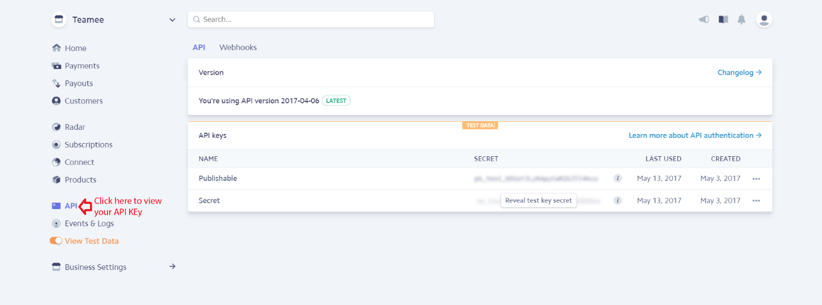

1. There are two keys, the first is your Publishable key and the second is the Secret Key.
2. Your Publishable Key should go into the checkout.js file (the checkout.js file is located in C:\xampp\htdocs\Teamee\public\js)

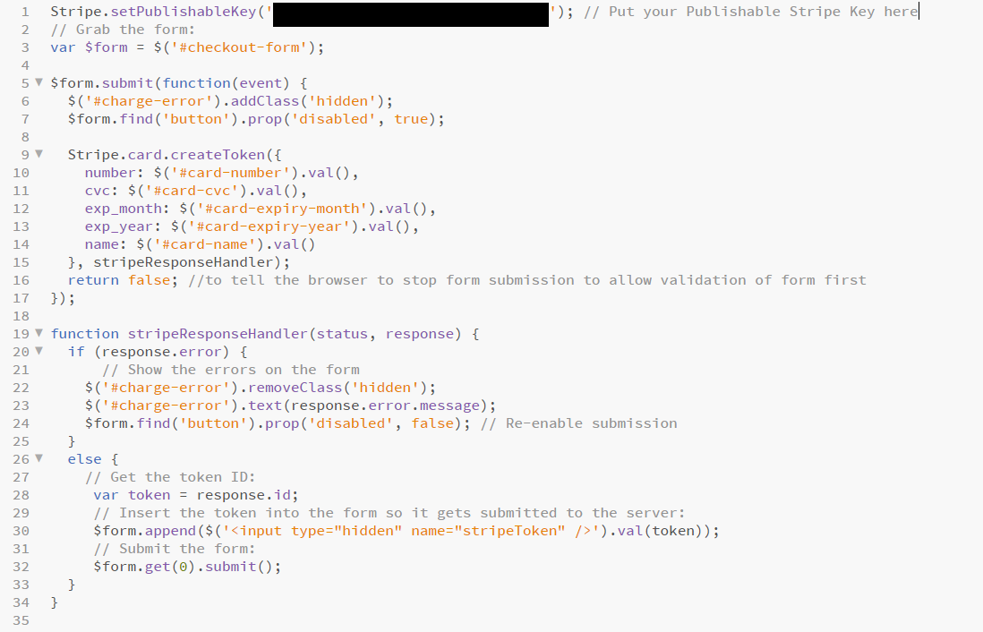

1. Your Secret Key goes into the ProductController.php file (found in C:\xampp\htdocs\Teamee\app\Http\Controllers)
2. Open the ProductController.php file and locate the postCheckout method and put your Secret Key into the area labelled in the picture below.

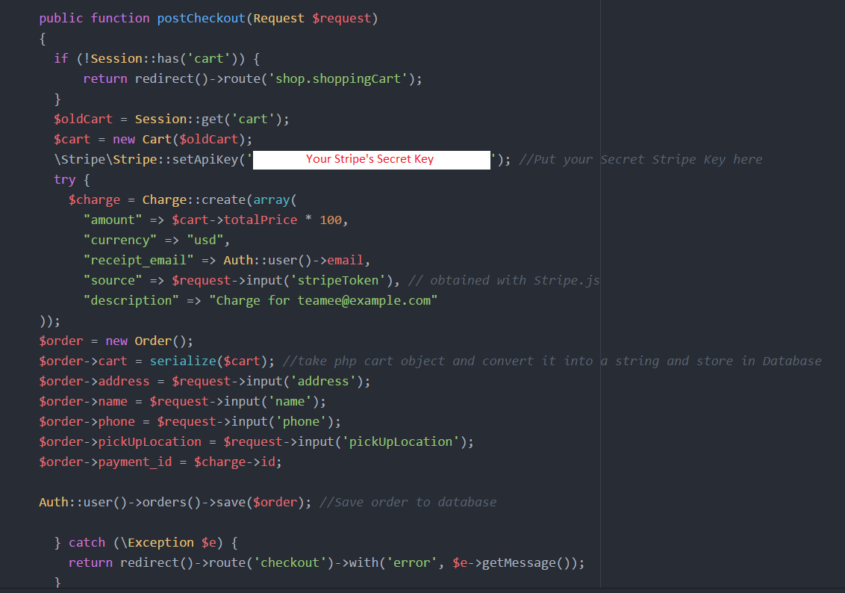

## Setup Laravel

1. Download Composer from <https://getcomposer.org/download/>
2. Install composer using the Composer-Setup.exe
3. After installation of composer is completed, open command and type in "composer install" while inside the Teame file.

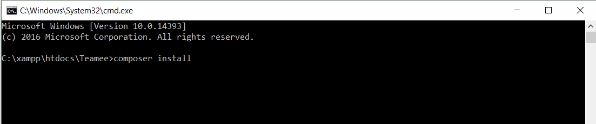

1. Start your server using Xampp
2. Type in “php artisan key:generate” in the commandline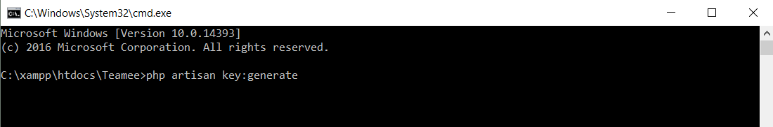

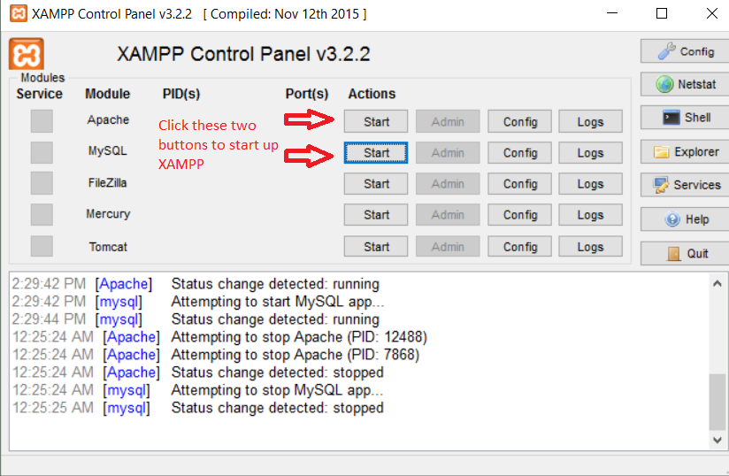

1. Go to your browser and access phpMyAdmin
2. Create a database

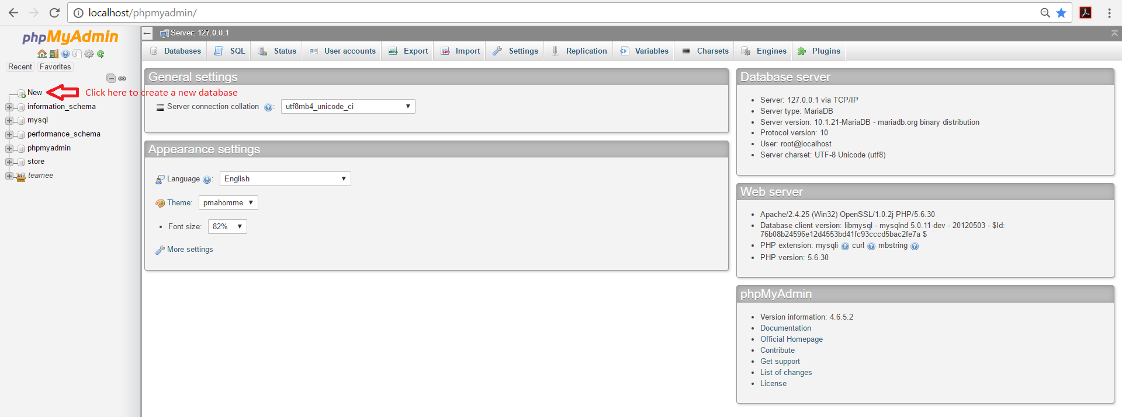

1. Hookup your database to the project by editing the .env file

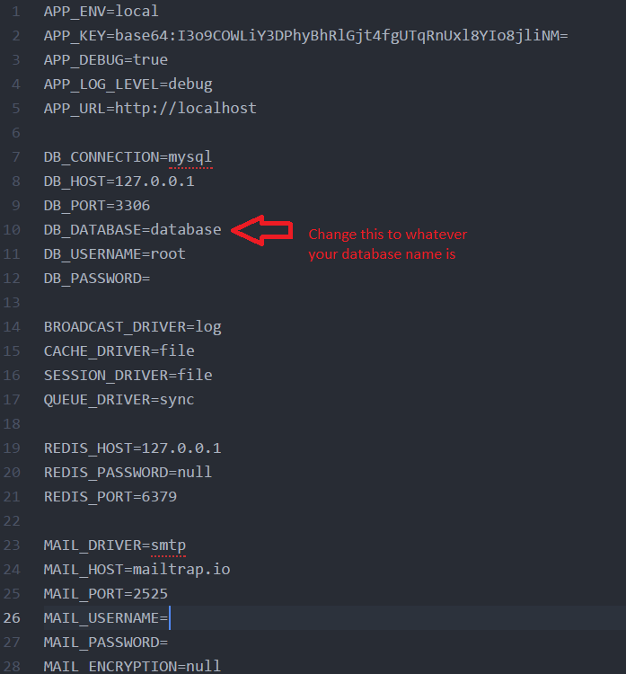

1. Whenever you edit the .env file, you have to close commandline and reopen it again.
2. Then use command line to migrate by typing “php artisan migrate”

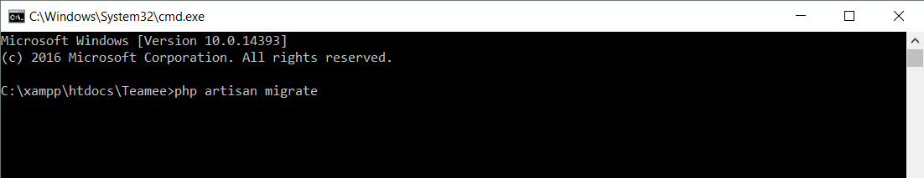

1. Then seed the database by typing in “php artisan db:seed”

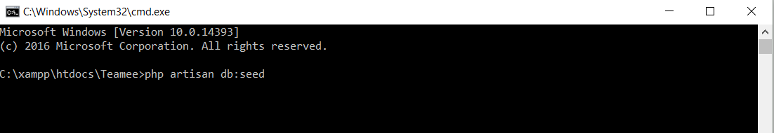

1. Then type the command “php artisan serve”

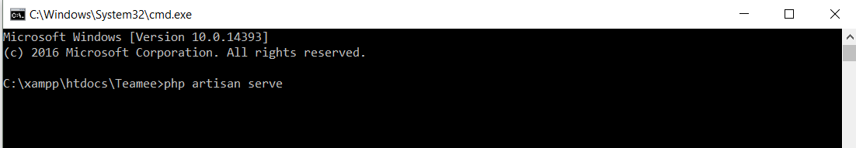

1. Open browser and view using localhost:8000/